Type 2 Liverpool Ringing Simulator
02 – Build & Installation Guide

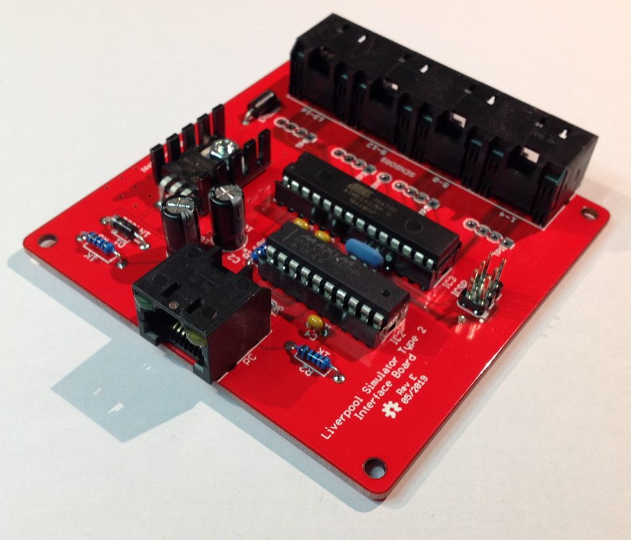

Author: Andrew Instone-Cowie
Date: 28 October 2026
Version: 1.10
Contents
Index of Figures 5
Index of Tables 7
Document History 8
Licence 10
Attribution 10
Documentation Map 11
About This Guide 12
Typical Simulator Installation 13
What You Will Need 14
Skills 14
Tools 14
Parts 14
PCBs 15
JLCPCB or SeeedStudio 15
OSH Park 19
PCB Design Software Change 19
Simulator Assembly 20
Polarised Components 20
Voltage Regulators 20
Diodes 21
Electrolytic Capacitors 21
Integrated Circuits 22
LEDs 22
Magneto-Resistive Sensors 23
Hall Effect Sensors 23
Simulator Interface Module 24
Parts List 24
Schematic 25
Parts 26
PCB Layout 26
Construction 27
Voltage Regulator 28
Power Module 31
Parts List 31
Schematic 32
Parts 33
PCB Layout 33
Construction 33
Magnetic Sensor Module 35
Parts List 36
Schematic 37
Parts 38
PCB Layout 38
Construction 39
Sensor Device Choice 40
Infra-Red & Other Sensor Modules 41
Parts List 41
Schematic 42
PCB Layout 43
Construction 43
Infra-Red Sensor 45
Enclosures 46
Parts List 46
Simulator Interface & Power Modules Enclosure 47
D Sub Serial Connector Alternative Drilling 48
Magnetic Sensor Module Enclosure 48
Infra-Red Sensor Module Enclosure 49
PCB Mounting Hardware 49
Grommets 50
Completed Assemblies 51
Simulator Interface Module 51
Power Module 51
Magnetic Sensor Module 52
Infra-Red Sensor Module 52
Firmware Upload 53
Hardware Programmer Options 54
Preparing the Environment 55
Preparing the Programmer 58
Setting the Fuses 62
Firmware Upload 67
Simulator Installation 69
Faculty Jurisdiction Rules 69
List B Application 69
Conditions 70
Simulator Interface Module 71
Power Module 71
Power Supply 72
Sensor Module Mounting 72
Magnet Mounting 74
Infra-Red Sensors 76
Reflector 76
Calibration 76
Cabling 77
Power/Data Cable 77
Sensor Cables 77
Computer Connection 78
Interface Module Setup 80
Connecting to the Interface Module 80
Worked Example 81
Sensor Channels 81
Example Installation 83
Default Settings 84
Disable Unused Channels 85
Re-Map Channels to Bells 86
Save Settings 87
Next Steps 88
Licensing & Disclaimers 89
Documentation 89
Software 89
Acknowledgements 90

Index of Figures
Figure 1 – Documentation Map 11
Figure 2 – Simulator General Arrangement 13
Figure 3 – PCB Panels of Sensor Boards 15
Figure 4 – JLCPCB Upload Box 16
Figure 5 – JLCPCB File Uploaded 16
Figure 6 – JLCPCB Gerber Viewer 16
Figure 7 – JLCPCB Completed Order Form 18
Figure 8 – Voltage Regulator Orientation 20
Figure 9 – Diode Orientation 21
Figure 10 – Electrolytic Capacitor Orientation 21
Figure 11 – Integrated Circuit Orientation 22
Figure 12 – LED Orientation 22
Figure 13 – Magneto-Resistive Sensor Orientation 23
Figure 14 – Hall Effect Sensor Orientation 23
Figure 15 – Simulator Interface Parts 26
Figure 16 – Simulator Interface Board Layout 26
Figure 17 – Voltage Check Pin Locations 28
Figure 18 – Bending Voltage Regulator Pins 29
Figure 19 – Voltage Regulator Heatsink 29
Figure 20 – Completed Simulator Interface Module PCB 30
Figure 21 – Power Board Parts 33
Figure 22 – Power Board Layout 33
Figure 23 – Completed Power Module PCB 34
Figure 24 – 2SS52M Magneto-Resistive Sensor Demonstration 35
Figure 25 – Magnetic Sensor Board Parts (2SS52M Version) 38
Figure 26 – Magnetic Sensor Board Layout 38
Figure 27 – Completed Magnetic Sensor Module PCB (A1120EUA-T, Right-Handed) 40
Figure 28 – Generic Sensor Board Layout 43
Figure 29 – Completed Generic Sensor Module PCB 44
Figure 30 – Infra-Red Sensor Wiring 45
Figure 31 – Simulator Interface & Power Module Enclosure Drilling Guide 47
Figure 32 – Alternative Drilling Guide for DB9 Connector 48
Figure 33 – Magnetic Sensor Module Enclosure Drilling Guide 48
Figure 34 – Infra-Red Sensor Module Enclosure Drilling Guide 49
Figure 35 – PCB Mounting Hardware 49
Figure 36 – Grommets Drilled & Cut 50
Figure 37 – Completed Sensor Interface Module 51
Figure 38 – Completed Power Board 51
Figure 39 – Completed Magnetic Sensor Module 52
Figure 40 – Completed Infra-Red Sensor Module 52
Figure 41 – Examples of Hardware Programmers 54
Figure 42 – Arduino IDE Preferences Menu 55
Figure 43 – Arduino IDE Sketchbook Location 56
Figure 44 – Arduino IDE Boards Manager Menu 57
Figure 45 – Arduino IDE Board Manager 58
Figure 46 – Arduino USB Cable 58
Figure 47 – Arduino IDE ISP Sketch Loading 59
Figure 48 – Arduino Programmer Board Selection 60
Figure 49 – Arduino Programmer Port Selection 60
Figure 50 – Arduino IDE ISP Upload 61
Figure 51 – Programmer with Capacitor 62
Figure 52 – Programmer Connections 62
Figure 53 – Programmer Connected to Interface Board 63
Figure 54 – Arduino IDE Target Board Selection 64
Figure 55 – Arduino IDE Programmer Selection 65
Figure 56 – Arduino IDE Burn Bootloader 66
Figure 57 – Arduino IDE Add Library 67
Figure 58 – Arduino IDE Firmware Upload 68
Figure 59 – Installed Simulator Interface 71
Figure 60 – Installed Sensor (Lois Weedon 4th) 72
Figure 61 – Installed Sensor (Lois Weedon 6th) 73
Figure 62 – Installed Sensor (Chirk, Type 1) 73
Figure 63 – Magnet Mounting Dimensions 74
Figure 64 – Magnet Mounting Construction 75
Figure 65 – Completed Magnet Mounting 75
Figure 66 – Sensor Daisy Chain 77
Figure 67 – 9-Pin Serial Port 78
Figure 68 – 9-Pin Serial Cable 78
Figure 69 – PC USB Ports 79
Figure 70 – USB to Serial Adapter 79
Figure 71 – PuTTY Configuration Dialogue 80
Figure 72 – Display Interface Settings 81
Figure 73 – Interface Channel Numbers 82
Figure 74 – Example Sensor Cabling 83
Figure 75 – Example Channel Connections 83
Figure 76 – Disabled Channels 84
Figure 77 – Default Settings 84
Figure 78 – Disabling Channels Example 85
Figure 79 – Channel Re-Mapping Example 87
Figure 80 – Example Channel Connections 87
Figure 81 – Saving Interface Settings 88

Index of Tables
Table 1 – PCB Ordering Parameters 17
Table 2 – Simulator Interface Module Parts List 24
Table 3 – Power Module PCB Parts List 31
Table 4 – Magnetic Sensor Module Parts List 36
Table 5 – Generic Sensor Module Parts List 41
Table 6 – Enclosures Parts List 46
Table 7 – Example Channel Mapping 86
Table 8 – Bell Numbers & Letters 86

Document History
Version | Author | Date | Changes
0.1 | A J Instone-Cowie | 10/09/2018 | First Draft.
0.2 | A J Instone-Cowie | 27/10/2018 | Minor corrections, PCB ordering, voltage regulator.
0.3 | A J Instone-Cowie | 02/11/2018 | Changed Farnell 1N4001 part code for a more available UK stocked item.
0.4 | A J Instone-Cowie | 24/01/2019 | Minor corrections, updated interface PCB to Rev D, added guidance on polarised components.
0.5 | A J Instone-Cowie | 05/02/2019 | Replaced Amphenol RJHSE-5080-02 (no longer stocked by Farnell) with AMP TE Connectivity 5406526-1.  Remove references to the Boardstuff programming shield, which is no longer available, and replace with examples of generic hardware programmers.
0.6 | A J Instone-Cowie | 10/02/2019 | Add diagram identifying pins for voltage checks.  Add link to GitHub repository Issues log.
0.7 | A J Instone-Cowie | 17/02/2019 | Correct diagram identifying pins for voltage checks.
0.8 | A J Instone-Cowie | 24/02/2019 | Rev C Power Board: Updated OSH Park link and board render.
0.9 | A J Instone-Cowie | 12/05/2019 | Add support for Second PC Board.
0.10 | A J Instone-Cowie | 09/06/2019 | Updated interface PCB to Rev E, added ceramic resonator as part of fix for Issue #3.  Added link to JLCPCB PCB manufacturer.
1.0 | A J Instone-Cowie | 03/08/2019 | First Release. Updated Power Board to Rev D, Second PC to Rev B, both with improved surge protection. Remove OSH Park permalinks,  Fixed dimension error on IR sensor enclosure. Add reference to enclosure drilling templates.
1.1 | A J Instone-Cowie | 30/09/2019 | Moved Second PC Board to new Multi-PC Guide.
1.2 | A J Instone-Cowie | 18/08/2020 | Minor update.
1.3 | A J Instone-Cowie | 22/07/2021 | Add notes about Faculty Jurisdiction, remove references to COVID-19.
1.4 | A J Instone-Cowie | 27/08/2021 | Alternative DB9 enclosure drilling option, DB9 part.
1.5 | A J Instone-Cowie | 19/06/2024 | Minor text updates, update faculty links, update external links.
1.6 | A J Instone-Cowie | 27/06/2024 | Updated Farnell/CPC/Screwfix part numbers, update PCB ordering information.
1.7 | A J Instone-Cowie | 28/08/2024 | Improve diagram following feedback.
1.8 | A J Instone-Cowie | 07/05/2025 | Eagle to KiCad PCB design tool migration. Updated schematics and board layouts (except MR sensor).
1.9 | A J Instone-Cowie | 09/07/2025 | Restyled MR sensor as “Magnetic Sensor” and added support for A1120EUA-T Hall Effect device.
1.10 | A J Instone-Cowie | 28/10/2026 | Update notes about Faculty Jurisdiction to reflect the migration to the Buildings Management Portal.

Copyright ©2018-26 Andrew Instone-Cowie.
Cover photograph: A completed Type 2 Simulator Interface Board.
PC ports vector graphic design by https://www.vecteezy.com
(Vecteezy Standard Licence, Free for personal and commercial use with attribution.)

Licence

This work is licensed under a Creative Commons Attribution-ShareAlike 4.0 International License.
Unless otherwise separately undertaken by the Licensor, to the extent possible, the Licensor offers the Licensed Material as-is and as-available, and makes no representations or warranties of any kind concerning the Licensed Material, whether express, implied, statutory, or other. This includes, without limitation, warranties of title, merchantability, fitness for a particular purpose, non-infringement, absence of latent or other defects, accuracy, or the presence or absence of errors, whether or not known or discoverable. Where disclaimers of warranties are not allowed in full or in part, this disclaimer may not apply to You.
To the extent possible, in no event will the Licensor be liable to You on any legal theory (including, without limitation, negligence) or otherwise for any direct, special, indirect, incidental, consequential, punitive, exemplary, or other losses, costs, expenses, or damages arising out of this Public License or use of the Licensed Material, even if the Licensor has been advised of the possibility of such losses, costs, expenses, or damages. Where a limitation of liability is not allowed in full or in part, this limitation may not apply to You.

Attribution
The Creative Commons Attribution-ShareAlike (CC BY-SA) licence permits you to re-use this material for any purpose you wish, subject to the conditions of the licence, including providing attribution of the source.
The following is suggested as a suitable form of attribution for this document, or extracts thereof:
Type 2 Build & Installation Guide, Liverpool Ringing Simulator Project (https://www.simulators.org.uk). This document is licensed under the CC BY-SA 4.0 licence (https://creativecommons.org/licenses/by-sa/4.0/). © 2018-2025 Andrew J Instone-Cowie.

Documentation Map

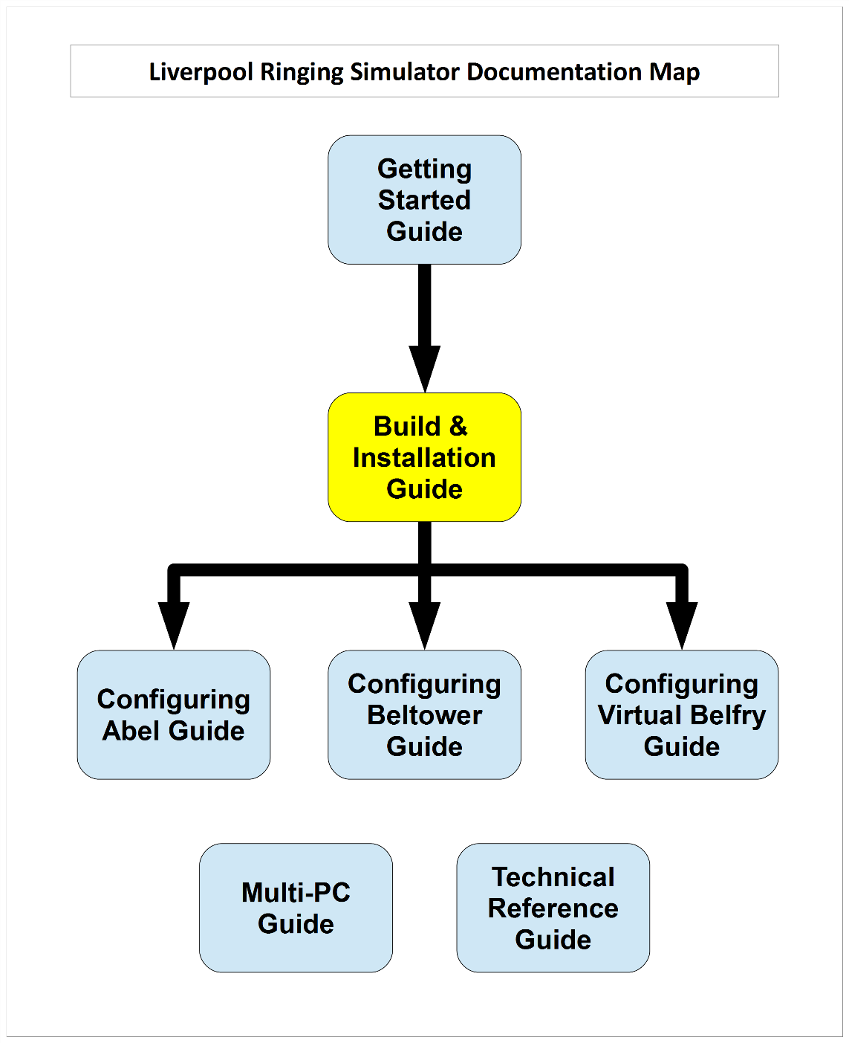
Figure 1 – Documentation Map

About This Guide
The Type 2 Liverpool Ringing Simulator allows sensors, attached to one or more real tower bells or teaching dumb bells, to be connected to a computer Simulator Software Package such as Abel, Beltower or Virtual Belfry. This allows you to extend and augment the teaching and practice opportunities in your tower.
The simulator is modular. This Build & Installation Guide shows you how to build and install the Simulator Interface module, Power module and Sensor modules hardware, install it in the tower, and set it up ready for your chosen Simulator Software Package.
In this guide you will find:
- Parts lists and schematics.
- Detailed construction and configuration information.
- Links to suggested sources of parts, including ready-made printed circuit boards and cables.
- Links to download the associated firmware source code, PCB CAD files and other supporting data hosted on GitHub.
- Guidance on installing the simulator hardware in the tower.
Configuration guides for the main Simulator Software Packages are available separately, as is a detailed Technical Reference Guide.
The Multi-PC Guide contains information on building the Second PC module or the Basic Serial Splitter module to allow multiple PCs to be used concurrently. If you are planning to run multiple PCs, it is strongly recommended that you complete and test the core Simulator modules first (Power, Interface, Sensors), before moving on to build the multiple PC modules.
Please note that this is a Build-it-Yourself project. No pre-built hardware is available.

Typical Simulator Installation
The following diagram illustrates the general arrangement of a Simulator installation using a sensor aggregation hardware interface like the Liverpool Ringing Simulator.
Multiple Sensor modules in the belfry, one per bell, are connected to a Simulator Interface module. A single data cable transmits the aggregated signals from the Simulator Interface module to the Simulator PC in the ringing room. The same cable feeds power from a low voltage power supply in the ringing room back up to the Simulator Interface to power both Interface and Sensor modules. The Type 2 simulator supports up to 16 sensors.
In the ringing room, a PC runs a Simulator Software Package which interprets the received signals and turns them into the simulated sound of bells.
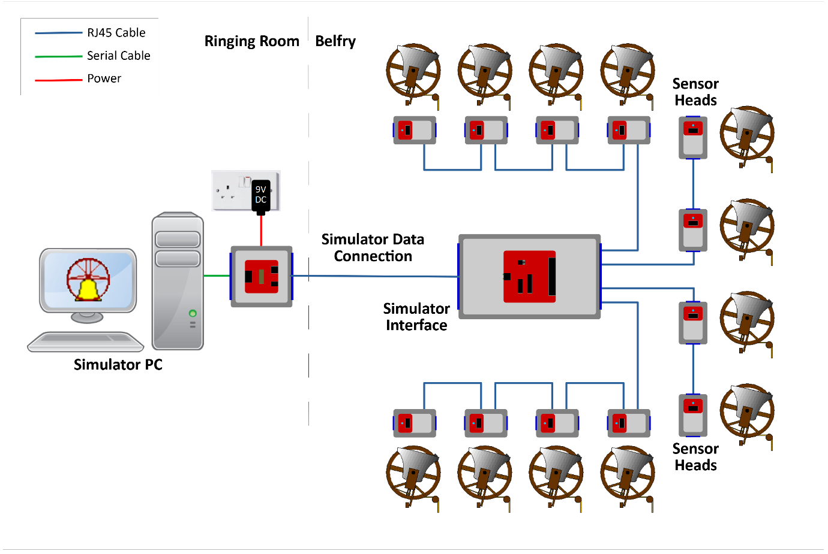
Figure 2 – Simulator General Arrangement
This guide provides detailed build and installation information for the Simulator Interface module, Power module and the Sensor modules. As an option, multiple Simulator PCs may be used concurrently; the options and setup for this are described in the separate Multi-PC Guide.

What You Will Need

Skills
The Liverpool Ringing Simulator is a Build-it-Yourself project. Based on feedback from constructors, the Type 2 simulator has been re-designed to be easier to construct and install than the original version, particularly around the cabling and enclosures.
Some prior experience of soldering and basic electronics kit construction will be helpful before you build the Type 2 Liverpool Ringing Simulator, but there is nothing complex in the design, and there are no surface mount components or cables to solder.
The ability to make simple voltage and resistance measurements with a multimeter will be helpful in troubleshooting, but more advanced diagnostic equipment is not required.

Tools
- A small soldering iron suitable for electronics use – around 15 Watts is fine.
- Fine rosin-cored electronics solder – NOT plumbers’ acid core solder.
- A small pair of side cutters.
- A small pair of needle nose pliers
- A 20mm hole saw & arbor (eg Screwfix parts 22647 & 7518H).
- A sharp utility knife.
- A 4.5mm drill bit.
- An electric drill – a bench mounted drill is best, but a hand-held drill can be used with care.
- Optional for optical sensors: An 18mm hole saw (eBay).
- Recommended: A basic multimeter with DC voltage and resistance ranges.

Parts
With the demise of Maplin, availability of electronic components from high street stores has been drastically reduced, and you will almost certainly need to source parts online. Suggested online suppliers include Farnell (and their CPC consumer division – particularly useful for cables) and Rapid Electronics. Parts may also be sourced from reputable suppliers on eBay.
- Farnell – https://uk.farnell.com
- CPC – https://cpc.farnell.com
- Rapid Electronics - https://www.rapidonline.com
- Switch Electronics - https://www.switchelectronics.co.uk/
- eBay – https://www.ebay.co.uk
Where possible, Farnell or CPC part numbers have been given. Note that some smaller parts will only be available in larger quantities than are required for a single simulator. You may want to use the leftovers to build more simulators for other local towers.

PCBs
Surplus development PCBs may be available from the Liverpool Ringing Simulator Project, please enquire about availability via the contact form on the website.
The core Type 2 simulator modules use three or four basic types of PCB:
- Simulator Interface Board – 1 required per installation
- Power Board – 1 required per installation
- Sensor Boards – 1 required per bell, per installation
Suggested sources of PCBs are JLCPCB and SeeedStudio in China, and OSH Park in the USA. All take typically around three weeks to deliver PCBs to the UK at lowest shipping cost, expedited options are available. PCB design files, known as “Gerber files”, are available from the project GitHub repository:
- https://github.com/Simulators/simulator-type2

JLCPCB or SeeedStudio
The most cost-effective way of obtaining PCBs is to order them from a Chinese PCB fabrication house, such as JLCPCB, or SeeedStudio’s “Fusion PCB” service. At the time of writing, 5 PCBs of a single design are available for as little as $2.00 US, plus postage.
The smaller Power and Sensor boards are designed as “panels” each containing multiple boards, four Power Boards or six Sensor Boards per panel. Each panel is treated as a single PCB by the fabricator, further reducing the total cost, so for example an order of 5 PCBs will result in enough boards for 30 sensors.
The following photograph shows panels of six Sensor Boards manufactured by SeeedStudio. These can easily be split into separate boards.
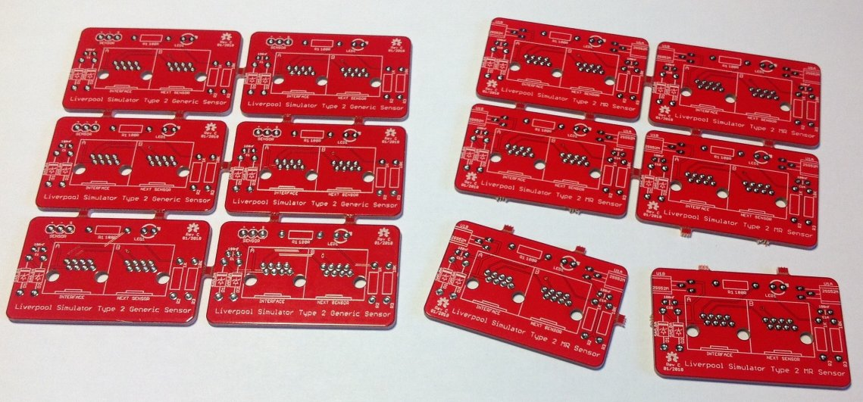
Figure 3 – PCB Panels of Sensor Boards
To order from JLCPCB or SeeedStudio, download the Gerber files from the project GitHub repository, then browse the following link to the service:
- https://jlcpcb.com
- https://www.seeedstudio.com/fusion_pcb.html
The ordering website for both manufacturers looks very similar, so only one (JLCPCB) is shown in the following examples.
For each zipped Gerber file in turn, upload by clicking the Add Gerber Files button, complete the order form, and add the boards to the shopping cart. Repeat the process with the Gerber file for each type of board you want to order. Before confirming each board, use the online Gerber Viewer to check that the board looks as it should. Follow the Gerber Viewer link in the upload box.
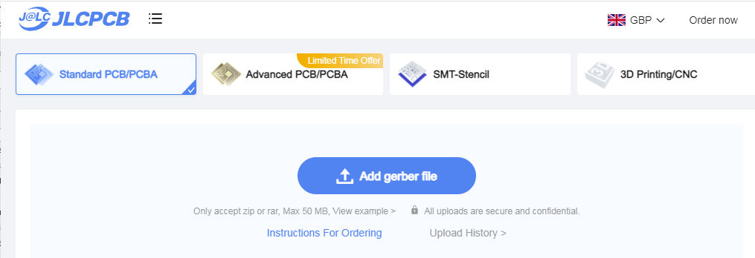
Figure 4 – JLCPCB Upload Box
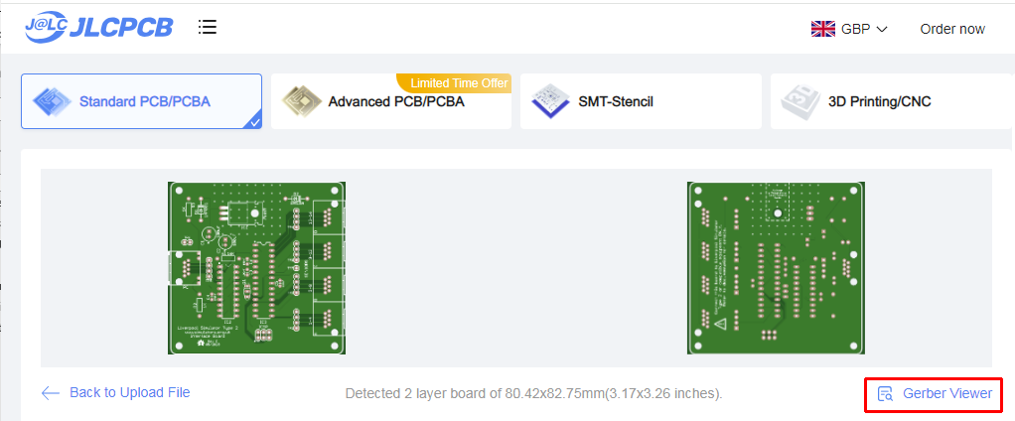
Figure 5 – JLCPCB File Uploaded
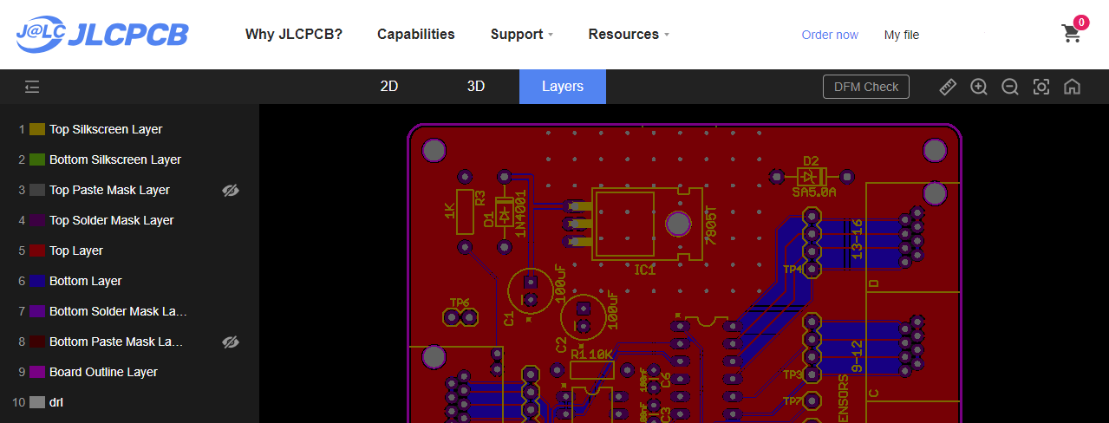
Figure 6 – JLCPCB Gerber Viewer

Return to the order form and complete it using the parameters below. Note that the parameters for the smaller, panelised boards are slightly different from the larger, single boards.
Table 1 – PCB Ordering Parameters
Form Field | Interface or Serial Splitter Boards | Power or Second PC Boards  (4-way Panelised) | MR or Generic Sensor Boards  (6-way Panelised)
Base Material | FR-4
Layers | 2
Dimensions | (Automatically detected from uploaded file)
PCB Qty | 5
Product Type | Industrial/Consumer (default)
Different Design | 1
Delivery Format | Single PCB | Panel by Customer | Panel by Customer
Panel Format Columns | N/A | 2 | 2
Panel Format Rows | N/A | 2 | 3
PCB Thickness | 1.6mm (default)
PCB Colour | Red
Silkscreen | White (default)
Surface Finish | HASL (with Lead) (default)
Outer Copper Weight | 1oz (default)
Via Covering | Tented (default)
Board Outline Tolerance | ±0.2mm (default)
Confirm Production File | No (default)
Remove Order Number | No (default)
Flying Probe Test | Fully Test (default)
Gold Fingers | No (default)
Castellated Holes | No (default)
Edge Plating | No (default)
An example of a completed JLCPCB order form (for an Interface Board) is shown below:
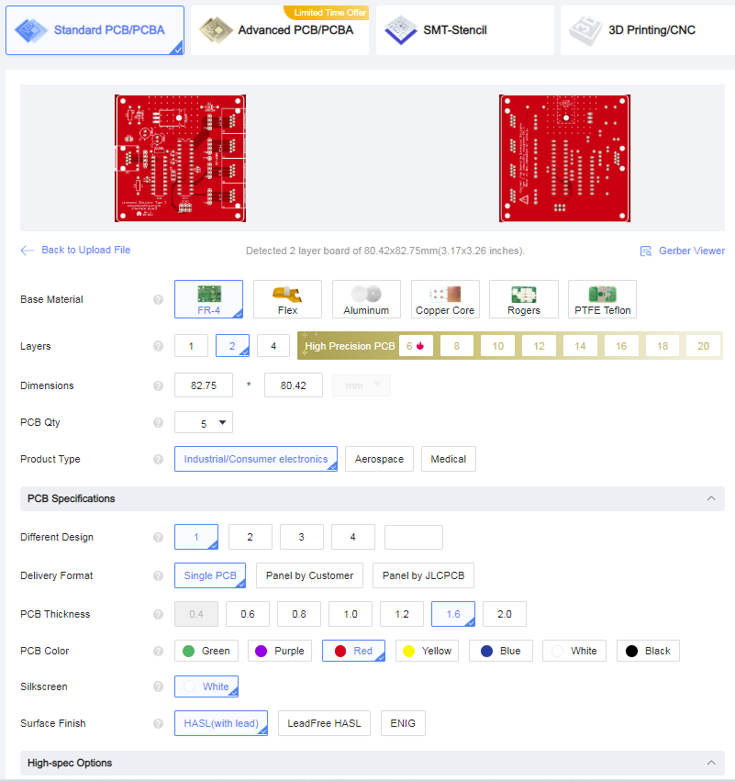
Figure 7 – JLCPCB Completed Order Form
- The PCB Dimensions should be detected automatically from the uploaded file.
- The Number of Different Designs is always 1, even for the panelised PCBs.
- All other settings should be as shown above.

OSH Park
PCBs can be obtained from the OSH Park service in the USA, and links to each board type are listed below. OSH Park produce very high quality “ENIG finish” boards, and currently charge $5 (US) per square inch for three copies of a single type of board, including international airmail shipping.
Do NOT try to order panelised PCBs from OSH Park using the panelised Gerber files! There is no cost advantage to doing so, and as OSH Park are themselves a panelisation service, trying to order panelised PCBs will most likely result in your order being rejected.
To order from OSH Park, download the Gerber files from the project GitHub repository, then browse the following link to the service and follow the instructions:
- https://oshpark.com

PCB Design Software Change
The Cadsoft Eagle design tool, now owned by AutoDesk, and originally used for all Liverpool Ringing Simulator Project PCBs, is being discontinued. As of May 2025, PCB designs have been migrated to the open source KiCad EDA package, and KiCad CAD files and KiCad-generated Gerber files have been made available in the GitHub repository.
The project documentation has also been updated with schematics and PCB layouts generated by KiCad, but board photographs may continue to show boards designed using Eagle. There may be cosmetic differences between the Eagle and KiCad versions of PCBs, but the functionality of the first KiCad and final Eagle versions of boards will be the same, except where noted otherwise.

Simulator Assembly
This section describes the assembly of the Simulator Interface module, Power module, and the Sensor modules. It also covers the suggested enclosures.
Before you start construction of the Simulator hardware, check the Release Notes and the issues log on the project GitHub repository for any open or late-breaking issues which may affect your build:
- https://github.com/Simulators/simulator-type2/issues
It is recommended to give the completed Simulator Interface and Sensor PCBs a coat of protective spray lacquer on both sides before installation, as a protection against damp. A suitable lacquer is Ambersil Acrylic Conformal Coating (Farnell 1666251). Protect the connectors and the ceramic resonator with masking tape before spraying.

Polarised Components
Several of the components of the Simulator are polarised and must be fitted the right way round for correct operation. Guidance is given below on correct orientation of the polarised components, but if in any doubt consult the component supplier or the manufacturer’s data sheets. Fitting a polarised component the wrong way round may result in damage to the component.

Voltage Regulators
The standard voltage regulator is fitted to the PCB with the metal tab flat against the surface of the board. The alternative Traco Power TSR 1-2450 regulator has pin 1 indicated with a white dot. If used, the alternative regulator must be fitted so that pin 1 is closest to the edge of the board, as shown in the following photograph.
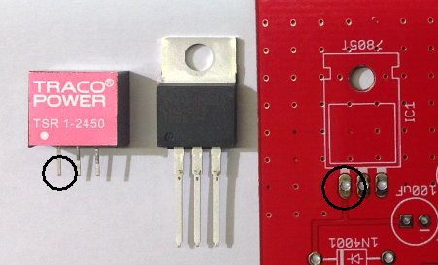
Figure 8 – Voltage Regulator Orientation

Diodes
The cathodes of the 1N4001 and SA5.0A diodes are indicated by a white band on the packages. The diodes must be fitted so that the white band aligns with the corresponding white band printed on the PCB, as shown in the following photograph.
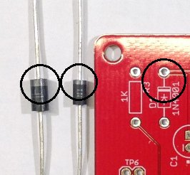
Figure 9 – Diode Orientation

Electrolytic Capacitors
The negative side of electrolytic capacitors is usually indicated by a shorter lead, and by negative markings on the side of the component. The electrolytic capacitors must be fitted with the negative lead through the hole marked with the corresponding negative sign and white dot printed on the PCB, as shown in the following photograph.
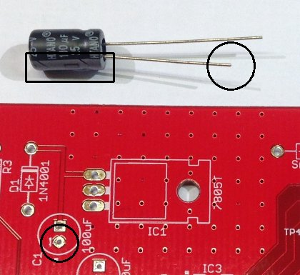
Figure 10 – Electrolytic Capacitor Orientation

Integrated Circuits
The two integrated circuits have pin 1 marked with a dot, and/or a notch in the end of the package. The ICs must be fitted with the notch/dot aligned with the notch and white dot printed on the PCB, as shown in the following photograph.
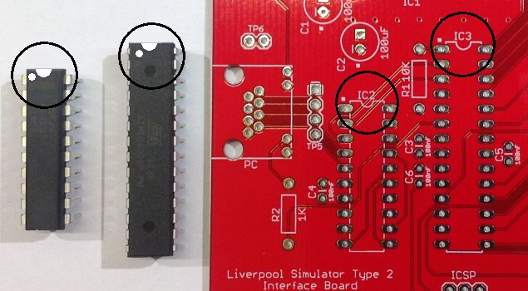
Figure 11 – Integrated Circuit Orientation

LEDs
The cathode of the LEDs is usually indicated by a shorter lead, and/or by a flat on the side of the plastic flange. The LEDs must be fitted with the cathode through the hole marked with the corresponding white dot printed on the PCB, as shown in the following photograph.
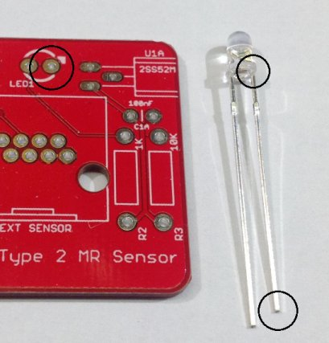
Figure 12 – LED Orientation

Magneto-Resistive Sensors
The 2SS52M magneto-resistive sensors are mounted flat on the PCB, with the chamfered and printed side uppermost, as shown in the following photograph.
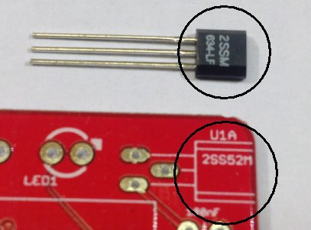
Figure 13 – Magneto-Resistive Sensor Orientation

Hall Effect Sensors
The A1120EUA-T Hall Effect sensors are mounted vertically on the PCB, with the chamfered and printed face pointing outward towards the edge of the board, as shown in the following photograph (prototype board shown, production board position is the same).
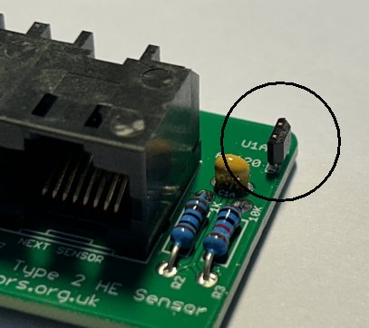
Figure 14 – Hall Effect Sensor Orientation

Simulator Interface Module
The Simulator Interface module contains the power supply for the interface and Sensor modules, the microcontroller, a RS-232 serial line driver, plus power and diagnostic LEDs, and an ICSP programming interface for firmware upload.

Parts List
Table 2 – Simulator Interface Module Parts List
Reference | Component | Notes
PCB | Type 2 Simulator Interface PCB
R1 | 10kΩ 0.25W Metal Film | Farnell 9341110
R2, R3 | 1kΩ 0.25W Metal Film | Farnell 9341102
C1, C2 | 100µF 25V Electrolytic (6.3mm Radial) | Farnell 9451188
C3, C4, C5, C6 | 100nF (0.1µF) 50V MLCC (2.54mm Radial) | Farnell 1457655
D1 | 1N4001 | Farnell 1458986
D2 | SA5.0A | Farnell 1886342
IC1 | MC7805CTG (replacement for LM7805)  (Alternative: Traco Power TSR 1-2450) | Farnell 9666095  (Farnell 1696320)
IC2 | MAX233EPP+G36 | Farnell 2519158
IC3 | ATmega328P-PU | Farnell 1715487
Q1 | Murata 8MHz Resonator CSTLS8M00G53-A0 | Farnell 2443273
PC Connector | Amphenol RJHSE-5084 | Farnell 1860578
Sensors Connector | Amphenol RJHSE-5080-04 | Farnell 2709010
ICSP Header | 2x3-pin 0.1” Male Header | Farnell 1593440
IC Socket | 20-pin, 0.3” pitch | Farnell 4285608
IC Socket | 28-pin, 0.3” pitch | Farnell 2445626
Hardware | M3 Bolt (6mm/9mm) Nut, & Washer | Use 9mm if fitting a heatsink
Heatsink | TO-220 Heatsink (Optional) | Farnell 1703172

Schematic
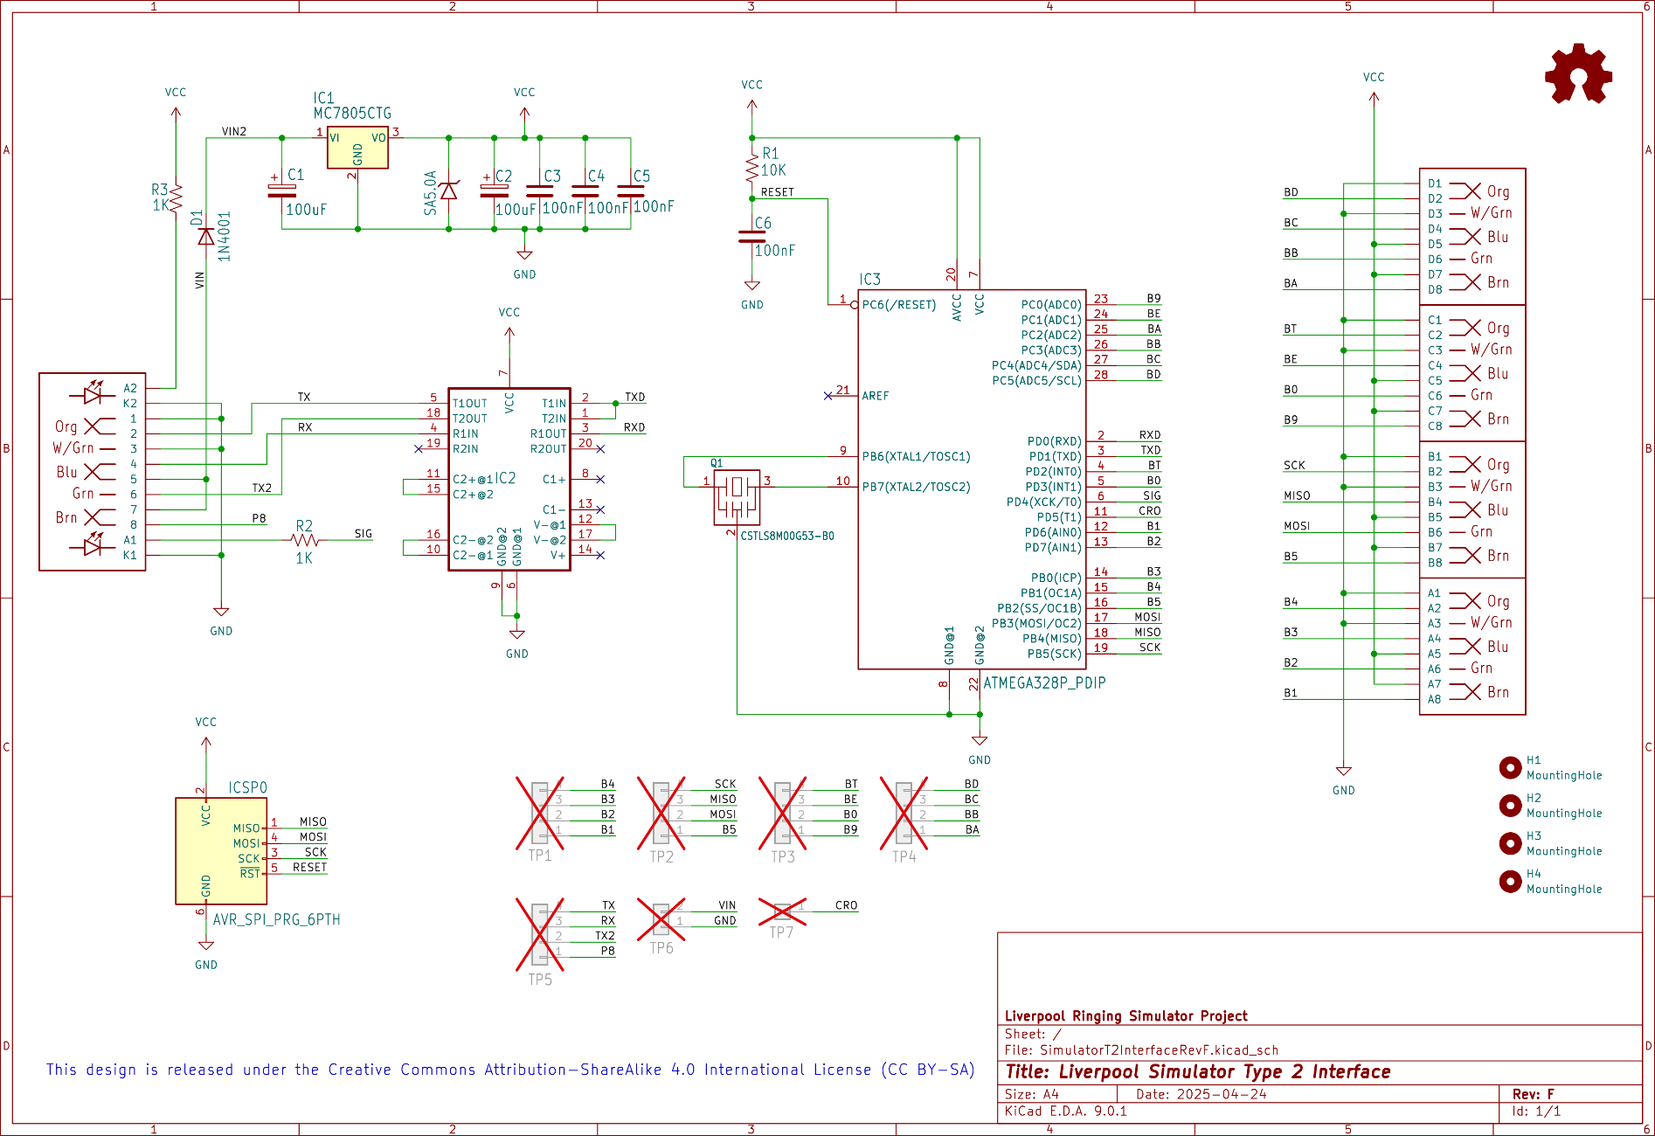

Parts
The following photograph shows the complete set of parts required for the Simulator Interface PCB.
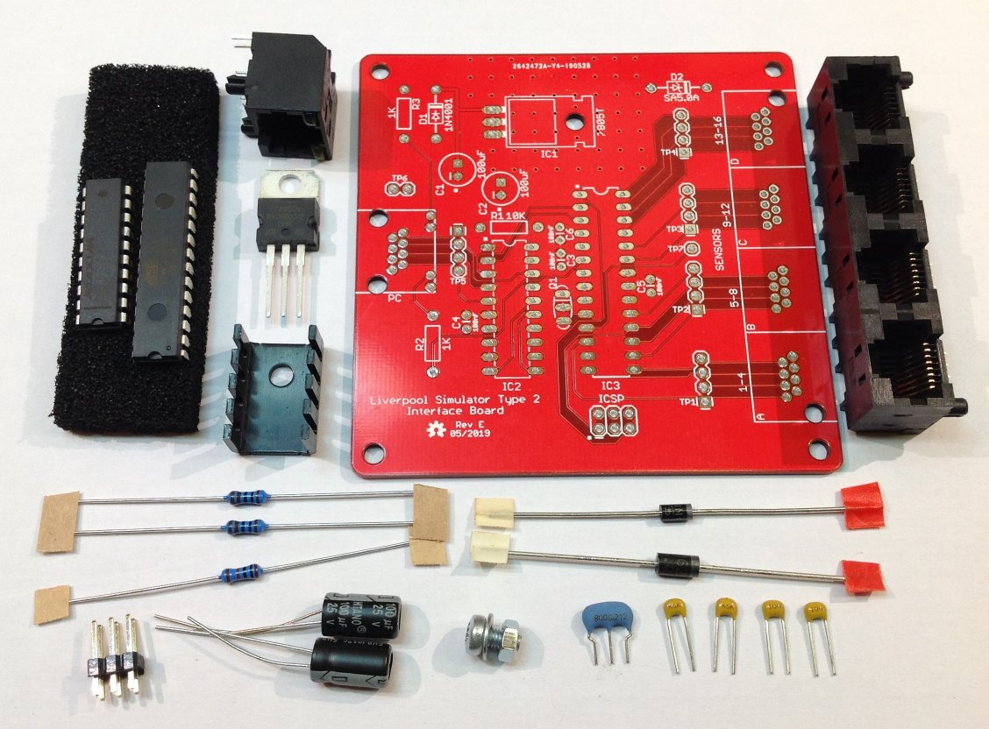
Figure 15 – Simulator Interface Parts

PCB Layout
The following diagram shows the layout of the Simulator Interface PCB. All components are mounted on the top (silkscreen) side of the board.
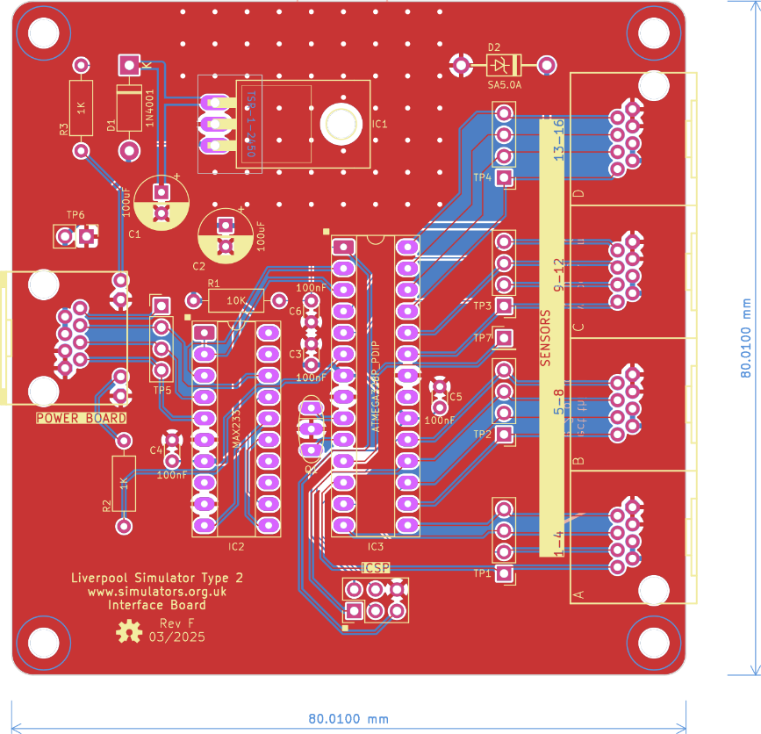
Figure 16 – Simulator Interface Board Layout

Construction
All the components on the Simulator Interface module are mounted on top, silkscreen, side of the board.
- Start by soldering the components with the lowest profile (resistors, ceramic capacitors), then the remainder of the components in order of increasing height, ending with the RJ45 sockets.
- The use of IC sockets for IC2 & IC3 is strongly recommended.
- When fitting the voltage regulator, carefully bend the pins through 90 degrees, as described below, so that the mounting hole in the tab lines up with the mounting hole in the PCB. Secure the regulator to the board with an M3 nut, bolt and washer before soldering the pins. A tiny smear of heatsink compound between the tab and board will improve heatsinking.
- There is no need to fit pins to any of the test point holes TP1 – TP7.
- If you plan to upload the firmware to the microcontroller in-situ using the method described below, fit the 2 x 3-pin ICSP header pins. These can be omitted if you are using a separate programmer or have obtained a microcontroller with the firmware already loaded.
- For high current installations, i.e. those with large numbers of optical sensors and/or very short power/data cable runs, consider replacing the linear regulator with a switched buck regulator such as the Traco Power TSR 1-2450. This is a direct drop-in replacement for the standard TO-220 package regulator. The buck regulator is much more efficient than the linear version, and reduces the heat dissipation.
- A small heatsink may be required for the voltage regulator, particularly in larger installations with higher current (e.g. optical) sensors. Consider using a buck regulator instead. A heatsink is not generally required for installations using the lower current magnetic sensors.
- Before fitting the socketed ICs, connect the board to a power supply (using the Power Board and a short RJ45 cable) and check using a multimeter that the supply voltage appears on the pins of TP6, and that +5V and 0V appear on the correct pins of the IC sockets. The pins are identified in the diagram below. The green power LED in the “PC” RJ45 connector should also light. Disconnect the power supply and fit the ICs.
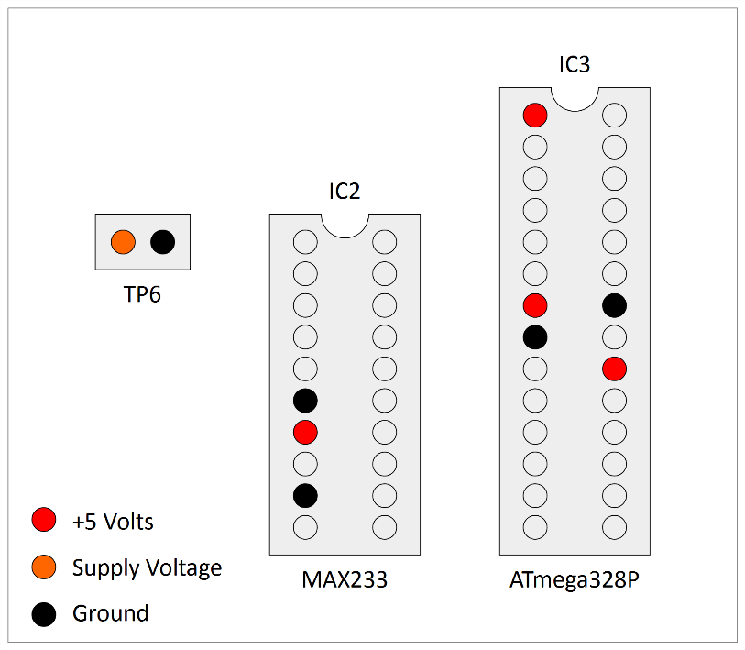
Figure 17 – Voltage Check Pin Locations
- If the board is powered up at this point with no firmware installed on the microcontroller, there will be no indication from the yellow diagnostic LED. This is normal.
- Pay close attention to the correct orientation of the polarised components D1, D2, C1, C2, IC1, IC2 & IC3.
- The mounting lugs of the RJ45 connectors clip into the holes in the PCB. Make sure the connector pins are correctly aligned with the holes before clipping the connector into the board, and then soldering the pins.
- Note that the connectors overhang the edges of the PCB slightly. This is intentional and is to allow for the board to be fitted into to a case in future.

Voltage Regulator

Bending Pins
The Simulator Interface Board PCB includes an alignment jig to assist you in bending the voltage regulator pins accurately.
- Bolt the voltage regulator to the reverse side of the board, at 90 degrees to its final position, so that the pins hang over the edge of the board.
- Support the pins close to the body of the voltage regulator with a matchstick, and then bend the pins carefully through 90 degrees, using the edge of the PCB as a guide.
- Fit the voltage regulator to the right side of the PCB, and the pins and fixing hole should be properly aligned.
- Bolt the voltage regulator to the PCB before soldering the pins.
- The process is illustrated in the following photograph.
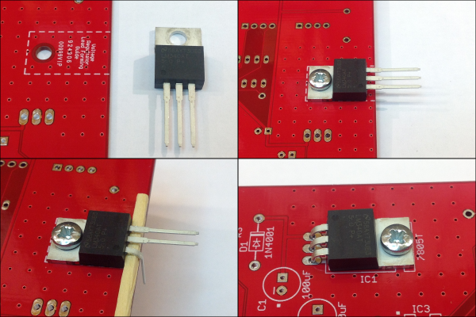
Figure 18 – Bending Voltage Regulator Pins

Heatsink
If you are fitting an additional heatsink to the voltage regulator, bolt the voltage regulator and heatsink to the PCB before soldering the pins. Make sure that the heatsink is not touching the PCB solder pads for the voltage regulator pins. A 9mm M3 bolt is required if fitting a heatsink.
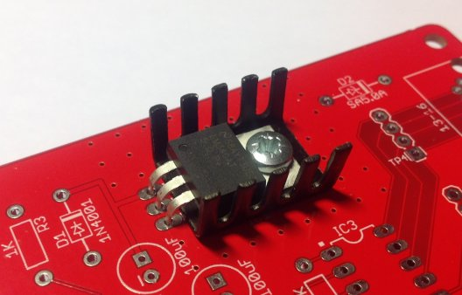
Figure 19 – Voltage Regulator Heatsink
A completed Simulator Interface Board PCB is shown in the following photograph.
Figure 20 – Completed Simulator Interface Module PCB

Power Module
The Power module is intended to be located close to the Simulator PC and enables the PC serial port (or a USB-Serial adapter), and the power supply, to be connected to the power/data cable which runs up to the Simulator Interface in the belfry. It also provides a protective fuse, and surge protection diodes on the power and serial lines.

Parts List
Table 3 – Power Module PCB Parts List
Reference | Component | Notes
PCB | Type 2 Power Board PCB
PC Connector | Right Angle PCB D Sub Connector 9 Pin | Farnell 1848372*
Interface Connector | Amphenol RJHSE-5080 | Farnell 1860577
Power Connector | DC Power Connector 5mm PCB Mount | Farnell 1854512
Fuse Holder | 20mm PCB Mount Fuse Holder | Farnell 2461158
Fuse | 20mm 800mA Quick Blow Fuse | Farnell 2461215
D1 | SA12A | Farnell 2679618
D2, D3, D4 | SA15CA | Farnell 2762809
(* Farnell part 1848372 has threaded screw lock posts for cable plugs fitted with locking screws. If you do not want these, use alternative part 1084701 instead.)

Schematic
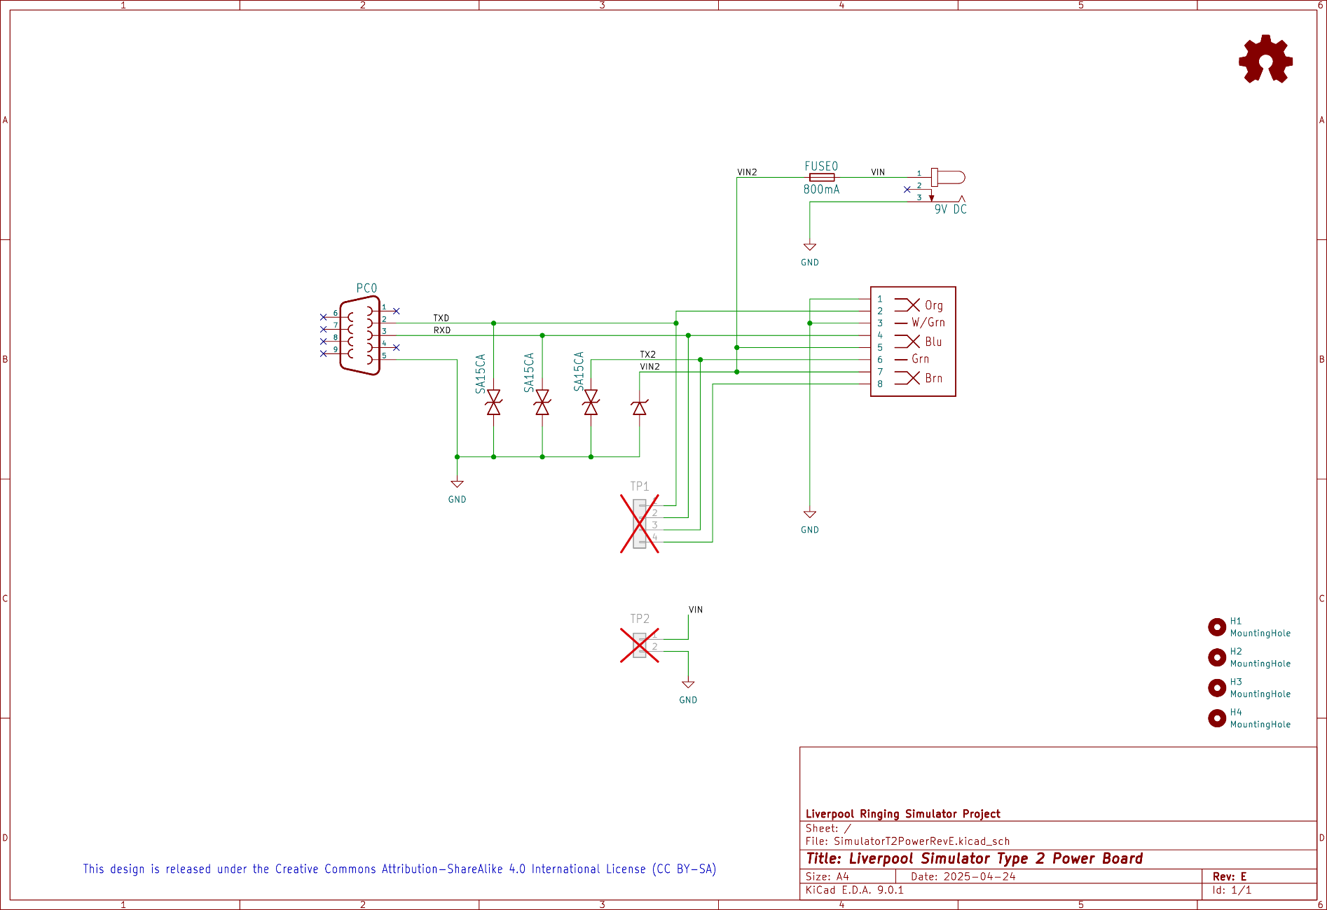

Parts
The following photograph shows the complete set of parts required for the Power Board PCB.
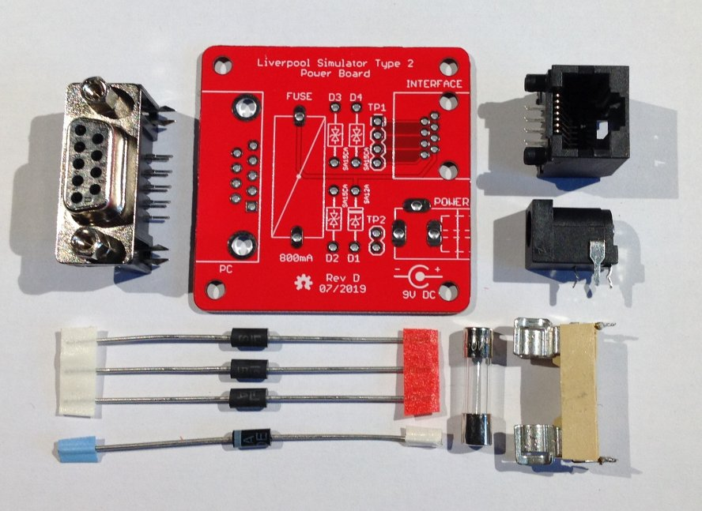
Figure 21 – Power Board Parts

PCB Layout
The following diagram shows the layout of the Power Board PCB. All components are mounted on the top (silkscreen) side of the board.
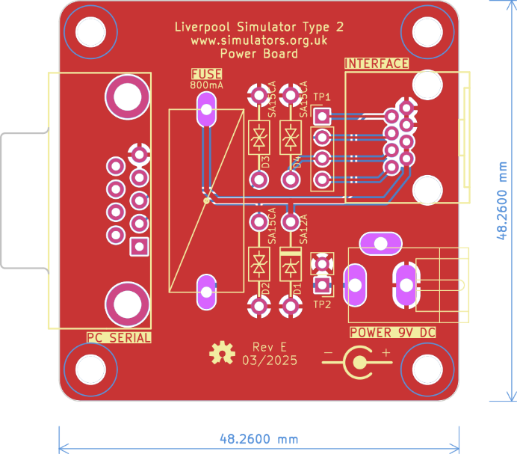
Figure 22 – Power Board Layout

Construction
All the components on the Power module are mounted on top, silkscreen, side of the board.
- If your Power Board came from a panelized PCB, lightly file down any remaining nibs from the edges of the board.
- Start by soldering the components with the lowest profile, then the remainder of the components in order of increasing height.
- Pay close attention to the correct orientation of the polarised diode D1. D2, D3 & D4 are not polarised.
- There is no need to fit pins to the test point holes TP1 – TP2.
- Fit a 20mm 800mA quick blow fuse to the fuse holder.
- Note that the connectors overhang the edges of the PCB slightly. This is intentional and is to allow for the board to be fitted into to a case in future.
A completed Power Board PCB is shown in the following photograph.
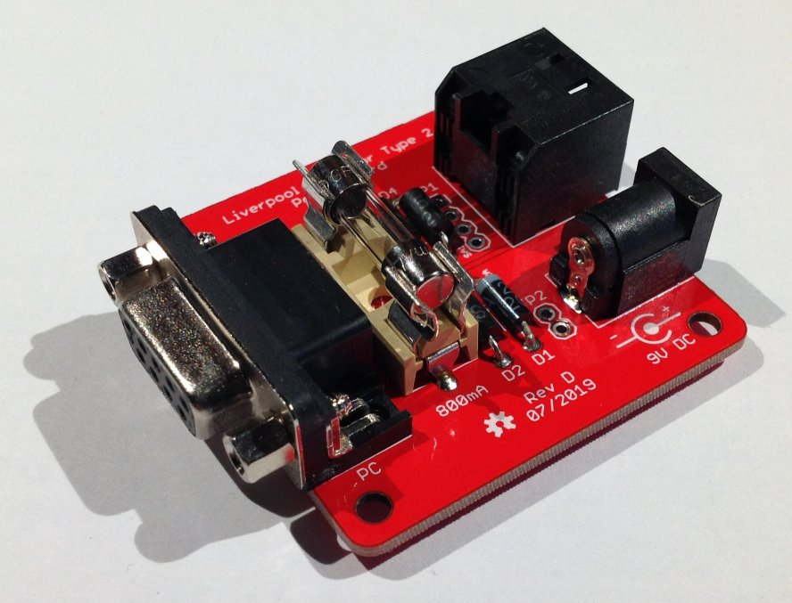
Figure 23 – Completed Power Module PCB

Magnetic Sensor Module
The magnetic sensor module, which is based on designs by Aidan Hedley, and Alan Griffin and Derek Livsey, uses either a Honeywell 2SS52M magneto-resistive sensor IC, or an Allegro Microsystems A1120EUA-T Hall Effect IC, activated by a small, powerful rare earth magnet mounted on the wheel shroud. These sensors have no moving or optical parts and are completely free of optical interference. They also draw much less current than most optical sensors.
Notes on the differences between the 2SS52M or A1120EUA-T devices are provided at the end of this section.
Using a magnet of the type suggested below, the absolute maximum operating distance of the 2SS52M sensor is approximately 60mm (face of magnet to face of sensor). In practice a maximum operating distance of approximately 30-40mm is recommended. The A1120EUA-T sensor has an absolute maximum activation range of approximately 47mm, so the distance between the magnet and the sensor should be reduced accordingly.
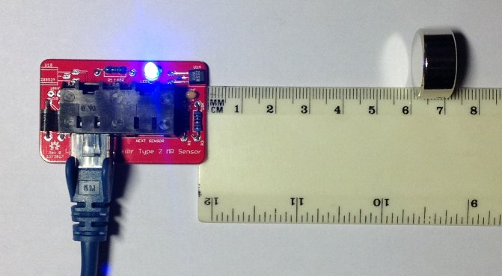
Figure 24 – 2SS52M Magneto-Resistive Sensor Demonstration
The sensor PCB contains all the components of the sensor, including the magnetic sensor itself, a diagnostic LED, and associated components. Build one sensor PCB for each bell you want to connect to the simulator.

Parts List
Table 4 – Magnetic Sensor Module Parts List
Reference | Component | Notes
PCB | Type 2 Magnetic Sensor PCB
R1 | 100Ω 0.25W Metal Film | Farnell 9341099
R2 | 1kΩ 0.25W Metal Film | Farnell 9341102
R3 | 10kΩ 0.25W Metal Film | Farnell 9341110
C1 | 100nF (0.1µF) 50V MLCC (2.54mm Radial) | Farnell 1457655
LED1 | Blue 3mm | Farnell 1863182
D1, D2 | SA5.0A | Farnell 1886342
IC1 | Honeywell 2SS52M  or  Allegro Microsystems A1120EUA-T | Farnell 3111519  or  Farnell 1791402
Connector | AMP TE Connectivity 5406526-1 | Farnell 2452587
Operating Magnet | N52 grade, 20mm x 10mm Neodymium

Schematic
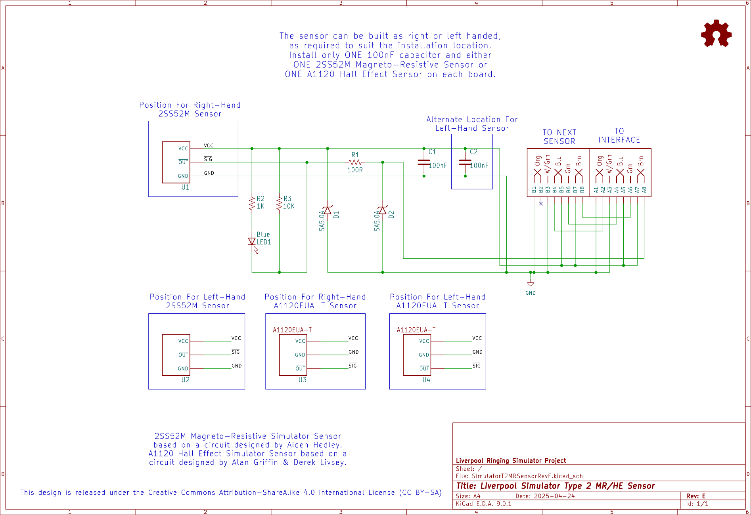

Parts
The following photograph shows the complete set of parts required for one Magnetic Sensor Board, in this case with the 2SS52M device. The A1120EUA-T device is visually very similar.
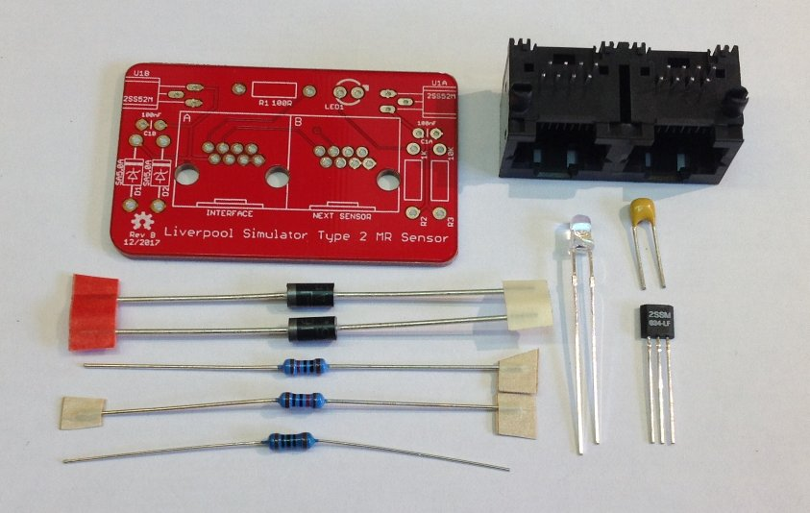
Figure 25 – Magnetic Sensor Board Parts (2SS52M Version)

PCB Layout
The following diagram shows the layout of a Magnetic Sensor PCB. All components are mounted on the top (silkscreen) side of the board.
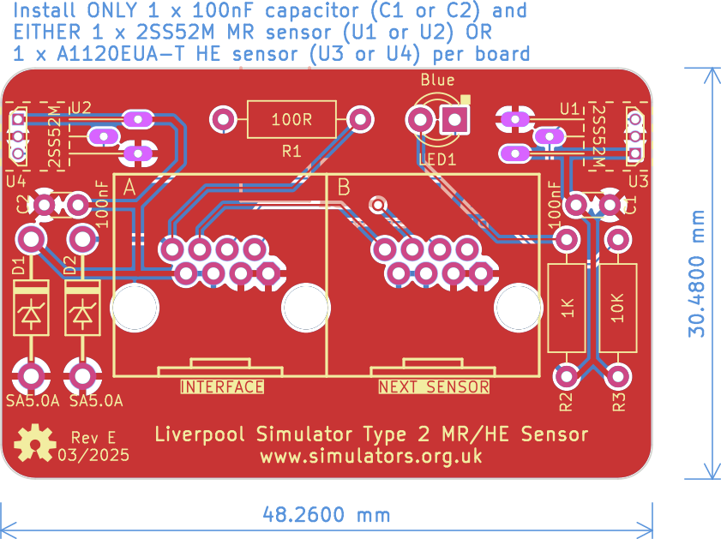
Figure 26 – Magnetic Sensor Board Layout

Construction
All the components on the Magnetic Sensor module are mounted on the top, silkscreen, side of the board.
- Install only ONE 100nF capacitor, and either ONE 2SS52M Magneto-Resistive Sensor or ONE A1120EUA-T Hall Effect Sensor on each board.
- If your Sensor Board came from a panelized PCB, lightly file down any remaining nibs from the edges of the board. The board is intended to be a close fit in the suggested enclosure.
- Sensors can be constructed as right-handed or left-handed, to suit the installation in the belfry. Fit capacitor C1 and a sensor at U1 or U3 for a right-handed sensor (as shown in the pictures in this section), or capacitor C2 and a sensor at U2 or U4 for a left-handed sensor.
- If using a 2SS52M device, start by fitting the sensor IC. Carefully bend the pins through 90 degrees using needle nose pliers, so that the sensor sits flat against the PCB, with the end of the sensor flush with the edge of the board.
- Then solder the remaining components, starting with those with the lowest profile (resistors, ceramic capacitors), then the remainder of the components in order of increasing height, ending with the RJ45 socket.
- The A1120EUA-T device stands vertically on the PCB, with the chamfered face towards the outer edge of the board. Take care soldering this device and use a fine-tipped soldering iron, as the pins are very close together.
- Pay close attention to the correct orientation of the polarised components D1, D2, LED1, and the sensor IC.
- The mounting lugs of the RJ45 connector clip into the holes in the PCB. Make sure the connector pins are correctly aligned with the holes before clipping the connector into the board.
- There is an additional mounting hole in the PCB which allows for the dual RJ45 connector to be replaced with a single RJHSE-5080 version in the “Interface” position. This is optional and intended for a sensor to be located at the end of a chain of sensors. To allow for maximum flexibility when cabling the sensors, you may choose to fit dual connectors to all sensor boards.
A completed right-handed A1120EUA-T Magnetic Sensor PCB is shown in the following photograph.
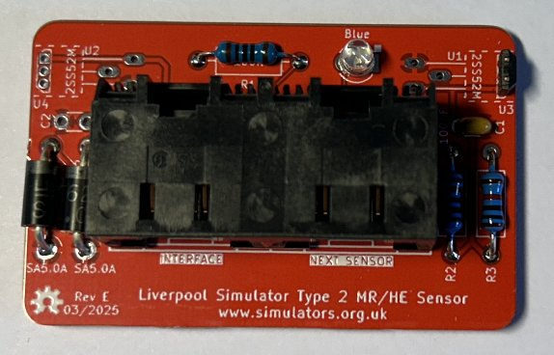
Figure 27 – Completed Magnetic Sensor Module PCB (A1120EUA-T, Right-Handed)

Sensor Device Choice
Each magnetic sensor PCB supports either one Honeywell 2SS52M or one Allegro Microsystems A1120EUA-T device, using a common PCB.
- The main advantage of the A1120EUA-T device over the 2SS52M is significantly reduced cost. The Cost Estimation Tool spreadsheet can be used to estimate the impact.
- The main disadvantages of the A1120EUA-T are that it is slightly less sensitive than the 2SS52M, and that it requires a specific magnet polarity.
- The A1120 device is not a direct drop-in replacement for the 2SS52M (the pinout and axis of magnetic sensitivity are different), so different PCB locations are provided for each type of device. In all other respects the sensor circuitry is similar, and A1120 sensors will interoperate with 2SS52M sensors should that be required.
- In bench tests, the A1120EAU-T maximum activation distance was approximately 47mm, and the release distance 56mm, coaxial with a 20x10mm N52 magnet, versus approximately 55-60mm for the 2SS52M sensor with the same magnet.
- Unlike the 2SS52M, the A1120EUA-T is sensitive to magnet polarity (a magnetic South pole activates the sensor), and the field axis is perpendicular to the face of the package. The 2SS52M is polarity insensitive, with the field axis parallel to the package leads.

Infra-Red & Other Sensor Modules
The Generic Sensor module is designed to allow other types of sensor to be connected to the simulator interface, provided these are electrically compatible with the system. It can also be used to build alternative infra-red sensors similar to those used in the original Liverpool Ringing Simulator.

Parts List
Table 5 – Generic Sensor Module Parts List
Reference | Component | Notes
PCB | Type 2 Generic Sensor PCB
R1 | 100Ω 0.25W Metal Film | Farnell 9341099
R2 | 1kΩ 0.25W Metal Film | Farnell 9341102
R3 | 10kΩ 0.25W Metal Film | Farnell 9341110
C1 | 100nF (0.1µF) 50V MLCC (2.54mm Radial) | Farnell 1457655
LED1 | Yellow 3mm | Farnell 2112098
D1, D2 | SA5.0A | Farnell 1886342
Sensor Header | 1x3-pin 0.1” Male Header  (cut from a longer strip) | Farnell 1462888
Connector | AMP TE Connectivity 5406526-1 | Farnell 2452587
Infra-Red Sensor | E18-D80NK Infra-Red Obstacle Sensor | Hobby Components  4tronix

Schematic
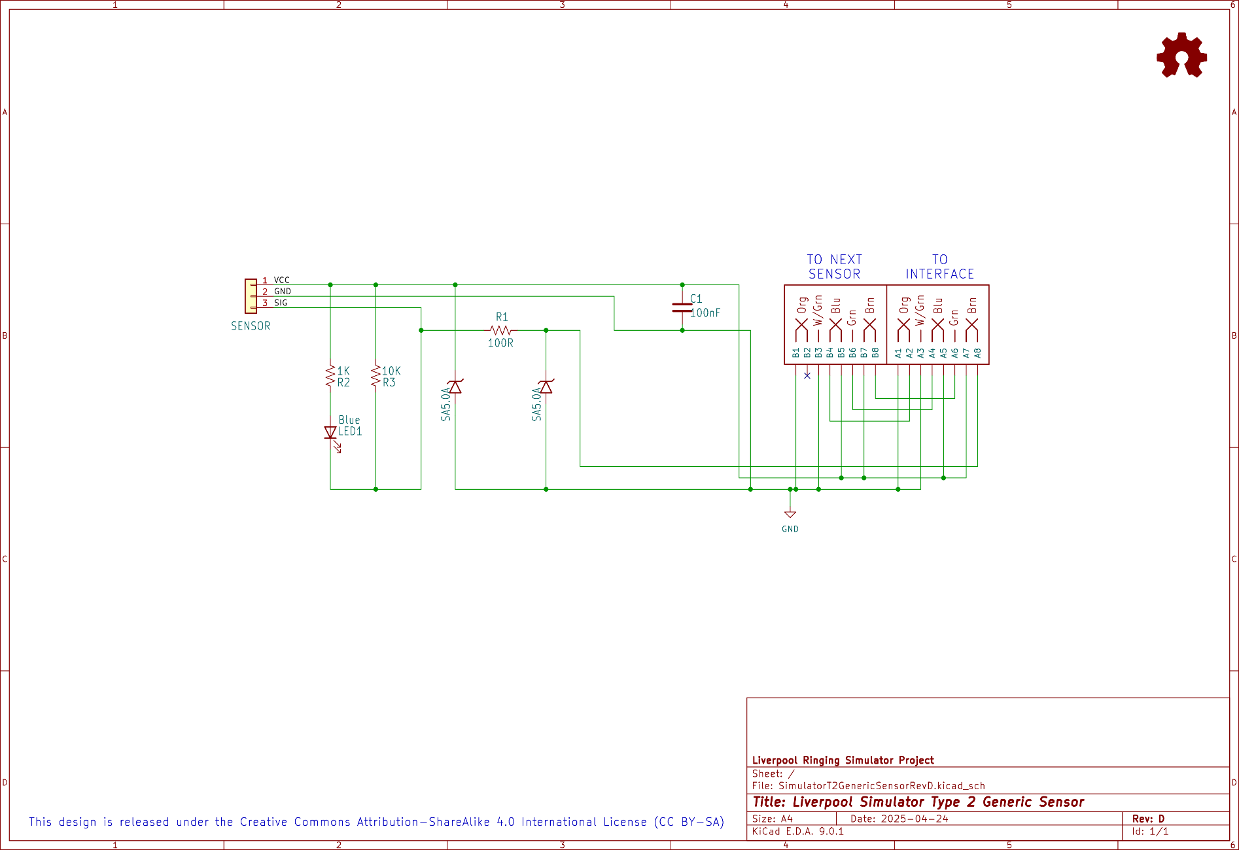

PCB Layout
The following diagram shows the layout of a Generic Sensor PCB. All components are mounted on the top (silkscreen) side of the board.
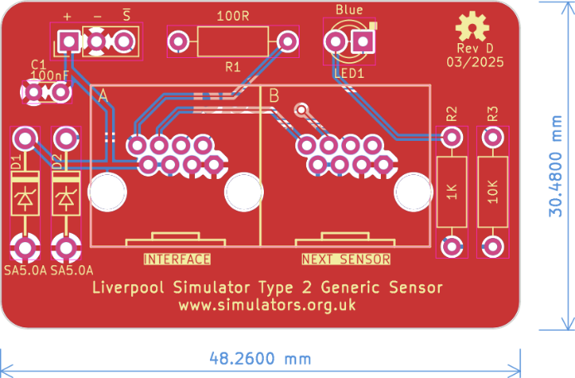
Figure 28 – Generic Sensor Board Layout

Construction
All the components on the Generic Sensor module are mounted on top, silkscreen, side of the board.
- If your Sensor Board came from a panelized PCB, lightly file down any remaining nibs from the edges of the board. The board is intended to be a close fit in the suggested enclosure when used to build an infra-red sensor.
- Solder the components, starting with the components with the lowest profile (resistors, capacitor), then the remainder of the components in order of increasing height, ending with the RJ45 socket.
- Pay close attention to the correct orientation of the polarised components D1, D2, LED1 (and to the connection to the infra-red sensor, if used).
- The mounting lugs of the RJ45 connector clip into the holes in the PCB. Make sure the connector pins are correctly aligned with the holes before clipping the connector into the board.
- There is an additional mounting hole in the PCB which allows for the dual RJ45 connector to be replaced with a single RJHSE-5080 version in the “Interface” position. This is optional and intended for a sensor to be located at the end of a chain of sensors. To allow for maximum flexibility when cabling the sensors, you may choose to fit dual connectors to all sensors boards.
A completed Generic Sensor PCB is shown in the following photograph.
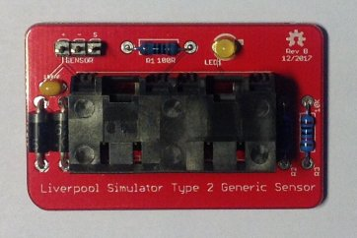
Figure 29 – Completed Generic Sensor Module PCB

Infra-Red Sensor
As an alternative to the magnetic sensors, an infra-red sensor can be built based on a commercially available modulated infra-red detector unit, marketed as an “obstacle sensor” for educational robotics projects. These sensors are available pre-assembled and are relatively inexpensive, and consequently the sensors are relatively straightforward to construct.
- The sensor emits and detects infra-red light modulated at high frequency. This makes the sensor much less sensitive than visible light or unmodulated infra-red sensors to interference from ambient lighting conditions.
- A 30mm length of 20mm black plastic conduit is used as a light shield. Once the sensor is fitted to the enclosure, lightly file or sand the exposed threads so that the shielding tube is a firm tight push fit on the end of the sensor.
- The infra-red sensor is mounted through the side of an enclosure using the plastic nuts supplied with the sensor. These should be tightened finger-tight only; do not use tools.
- It is essential to check that order of the wires in the sensor connector matches the order of the pins. The red (+5V) wire should go to the leftmost pin, the black (0V) wire to the centre pin, and the yellow (signal) wire to the rightmost pin.
- If the wires in the connector are in a different order, re-arrange them by gently prising up the plastic tabs and sliding the pin out of the housing. Slide them back in in the correct order, ensuring that the plastic tabs are gently pushed down to lock them in place.
The wiring of the infra-red sensor is illustrated in the following diagram:
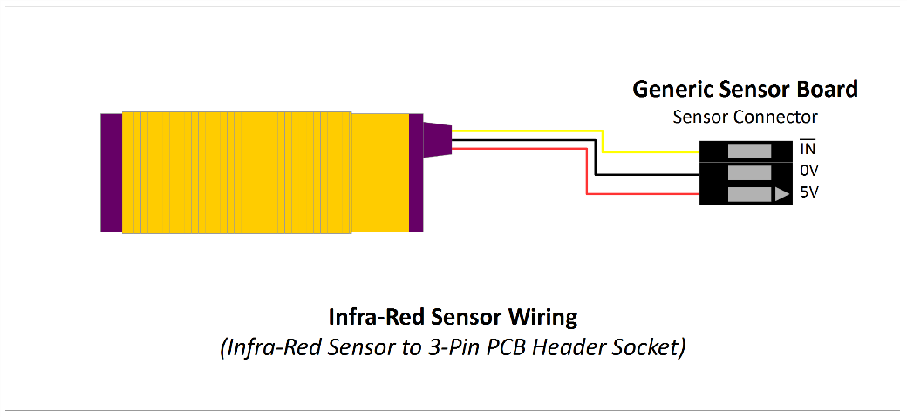
Figure 30 – Infra-Red Sensor Wiring

Enclosures
The suggested enclosures for the Simulator Interface, Power and Sensor moduless are from the “Really Useful” series of plastic boxes, widely available from hobby and stationery shops, or direct from the manufacturer.
- Drilling large diameter holes with twist drills can result in bit grabbing and damage to the enclosure. Use a 20mm hole saw for cable holes, this makes the process of drilling the enclosure much easier and safer.
- Support the inside surface of the enclosure with a block of scrap wood when cutting the holes and cut at a low speed.
- Clean up any rough edges or swarf with a sharp knife.
- Drill any additional holes required in the base of each sensor enclosure to suit your mounting method.
- Cables are run into the enclosures via PVC grommets, which provide some protection against dust and moisture.
- A set of suitable paper templates is available from the GitHub repository as a PDF and should be printed out full size with no scaling.

Parts List
Table 6 – Enclosures Parts List
Reference | Component | Notes
Simulator Interface Board | Really Useful Box® 0.75 Litre | 195 x 135 x 55mm
Power Board | Really Useful Box® 0.75 Litre | 195 x 135 x 55mm
Magnetic Sensor | Really Useful Box® 0.07 Litre | 90 x 65 x 30mm, 1 per Sensor
Infra-Red Sensor | Really Useful Box® 0.14 Litre | 90 x 65 x 55mm, 1 per Sensor
Grommets | 20mm Closed Grommets | Screwfix 884VT
Hardware (Optional) | M3 x 12mm Nylon PCB Standoffs | eBay

Simulator Interface & Power Modules Enclosure
The following diagram shows the holes required in a 0.75 litre Really Useful Box for both the Simulator Interface and Power boards.
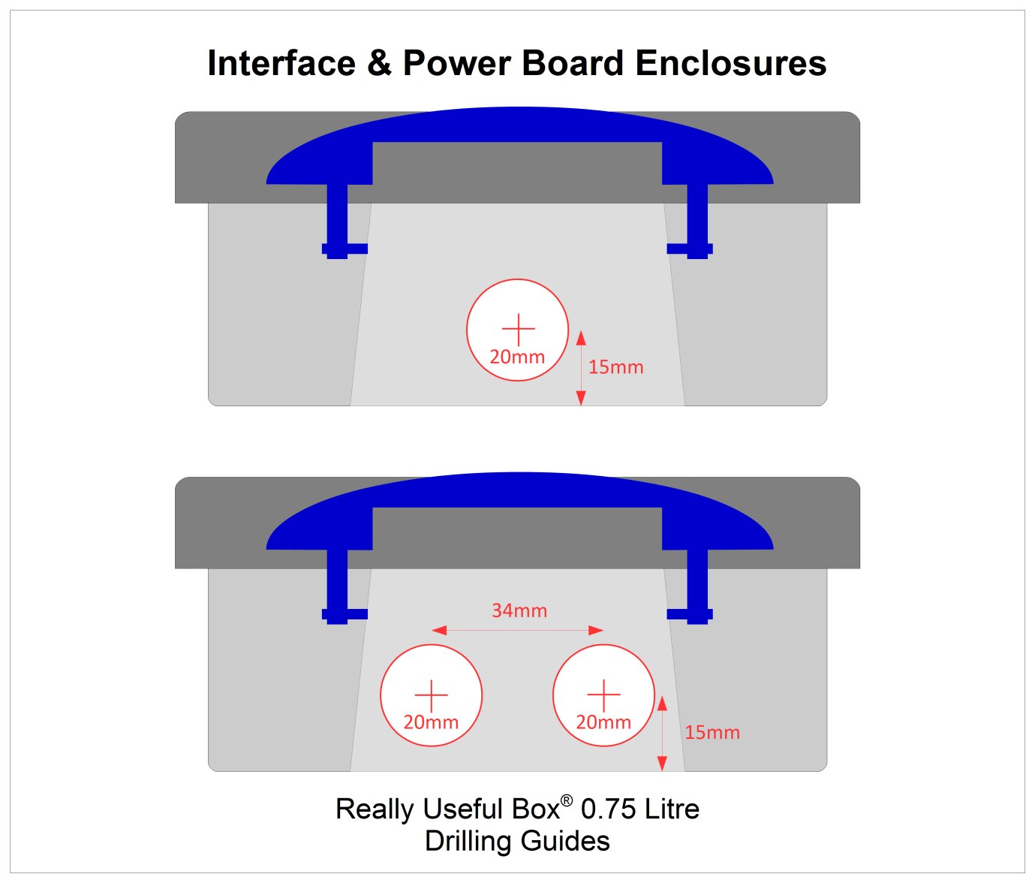
Figure 31 – Simulator Interface & Power Module Enclosure Drilling Guide

D Sub Serial Connector Alternative Drilling
The single 20mm hole in the Power Module enclosure is sufficient for a USB-Serial adapter with a USB-A connector. If you are using an RS-232 cable with a 9-pin D Sub Connector, then a larger hole will be required. Drill two 20mm holes and cut out the area between them as shown by the dotted lines in the diagram below.
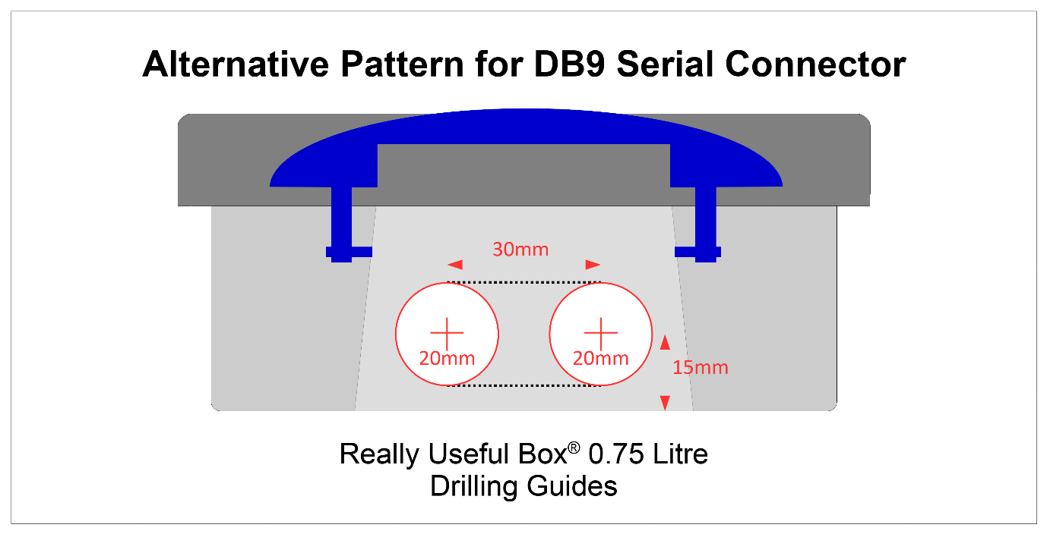
Figure 32 – Alternative Drilling Guide for DB9 Connector

Magnetic Sensor Module Enclosure
The following diagram shows the hole required in a 0.07 litre Really Useful Box for the Magnetic Sensor Board. The hole will catch the overhanging lip of the box slightly; this does not matter. There is no difference between right-hand and left-hand sensors.
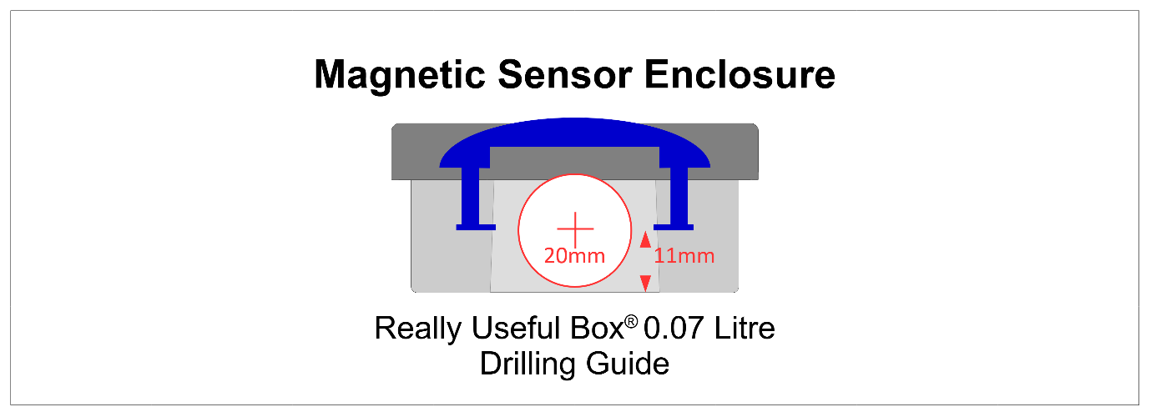
Figure 33 – Magnetic Sensor Module Enclosure Drilling Guide

Infra-Red Sensor Module Enclosure
The following diagram shows the holes required in a 0.07 litre Really Useful Box for an infra-red sensor using the Generic Sensor Board. Cut the 18mm hole to suit either a right-hand or left-hand installation as needed.
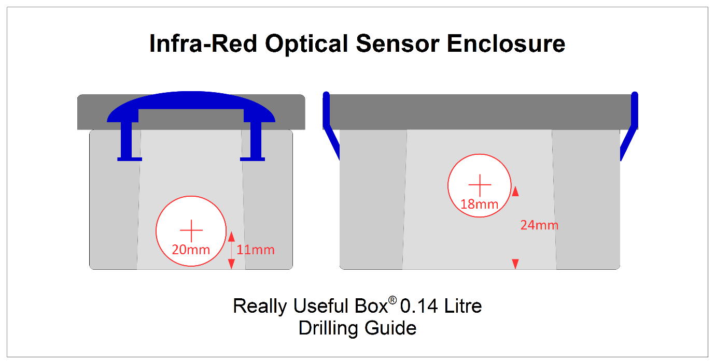
Figure 34 – Infra-Red Sensor Module Enclosure Drilling Guide

PCB Mounting Hardware
Optionally, the Interface and Power module PCBs may be secured to the base of the enclosure using M3 x 12mm Nylon PCB standoffs, nuts, screws and washers.
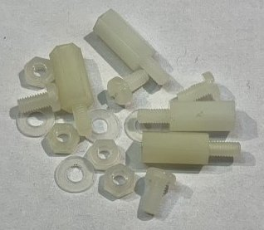
Figure 35 – PCB Mounting Hardware

Grommets
Cables are run into the enclosures via PVC grommets, which provide protection against dust and moisture.
- Drill one or two holes in each closed grommet. A diameter of 4.5mm should ensure a snug fit around the RJ45 cables, but this can be adjusted to suit.
- For sensors, offset the holes slightly, as shown in the twin hole example below, as this allows the cables to sit closer to the base of the enclosure.
- Using a sharp knife, make a cut as shown from the hole (link the holes if there are two), through the edge of the grommet.
The following diagram shows examples of the holes and cuts required in the grommets.
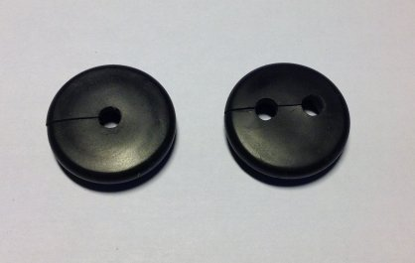
Figure 36 – Grommets Drilled & Cut

Completed Assemblies

Simulator Interface Module
The following photograph shows a completed Sensor Interface, with lid off and cables installed for four chains of sensors.
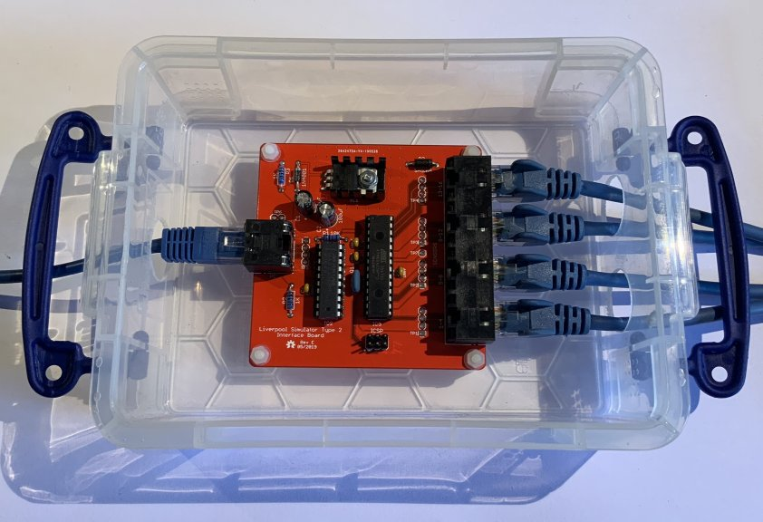
Figure 37 – Completed Sensor Interface Module

Power Module
The following photograph shows a completed Power module, with a USB-Serial adapter also inside the enclosure.
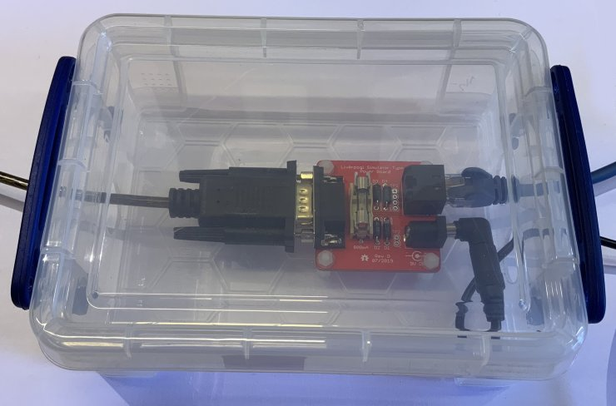
Figure 38 – Completed Power Board

Magnetic Sensor Module
The following photograph shows a completed Magnetic Sensor module with a 2SS52M magneto-resistive sensor. The PCB is a snug fit in the bottom of the enclosure. If the sensor is to be mounted vertically, a cable tie around the RJ45 cables on the inside of the box will stop the board from slipping down the inside of the box.
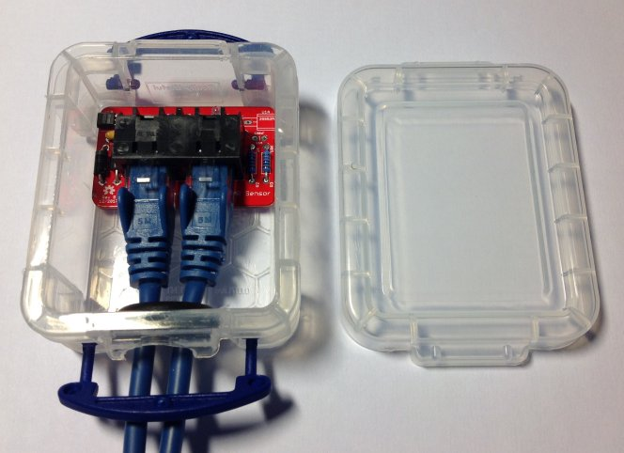
Figure 39 – Completed Magnetic Sensor Module

Infra-Red Sensor Module
The following photograph shows a completed infra-red sensor module, using a Generic Sensor Board.
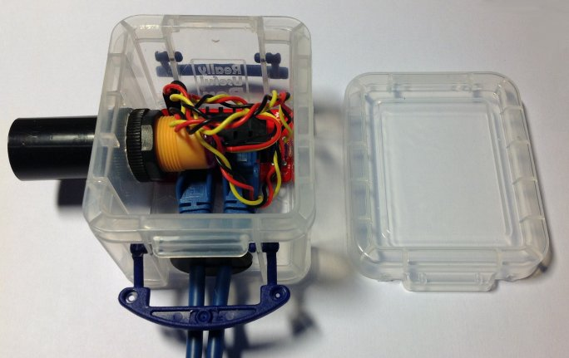
Figure 40 – Completed Infra-Red Sensor Module

Firmware Upload
Note: If you have obtained a microcontroller from the project with the firmware already uploaded to it, you can skip the whole of this section, and move on to the Installation section.
The firmware for the Simulator Interface Board is released under the GNU General Public Licence (GPL), Version 3, and the source code and other supporting files can be downloaded from GitHub.
- https://github.com/Simulators/simulator-type2
The Simulator Interface firmware is held in non-volatile flash memory on the ATmega328P microcontroller. It should only be necessary to re-upload the software if the microcontroller is replaced, the flash memory has become corrupted, or the Simulator Interface firmware requires updating.
The firmware code needs to be uploaded to the microcontroller on the Simulator Interface PCB. Although the software development environment is based on the Arduino platform, the Simulator Interface does not use the Arduino bootloader, and it is not possible to upload the firmware over the interface’s RS-232 serial port. Firmware is uploaded using a hardware programmer via the ICSP header pins provided on the interface PCB.
There are three main options for the hardware programmer:
- A dedicated hardware ISP programmer such as the Microchip Atmel ICE.
- An Arduino add-on board or shield such as the Arduino ISP or similar shield.
- An Arduino board (with one additional component) used as an ISP programmer.
The last of these requires no special hardware, and is the approach described in this document. There are also many tutorials online, including on the Arduino website.

Hardware Programmer Options
The following photograph shows two examples of hardware programmers. On the left, an ArduinoISP device is connected directly the ICSP programming pins of a completed Simulator Interface PCB. On the right, a generic programming shield (mounted on an Arduino Uno board) can be used to upload firmware to the microcontroller before it is installed on the Simulator Interface PCB.
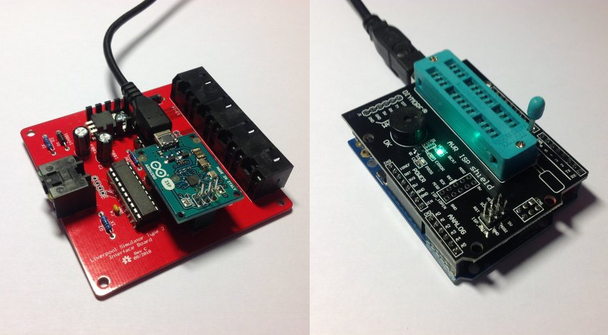
Figure 41 – Examples of Hardware Programmers
If you have access to a hardware programmer, then you can use this to upload firmware to the ATmega328P microcontroller. This guide describes an alternative method adapting an Arduino Uno board as a programmer.

Preparing the Environment
Perform the following steps to prepare the PC software environment for compiling and uploading the Simulator Interface firmware:
- Download and install the latest version of the Arduino “Legacy IDE” package. At the time of writing this was version 1.8.19.
- Start the IDE and open the program preferences by selecting File | Preferences.
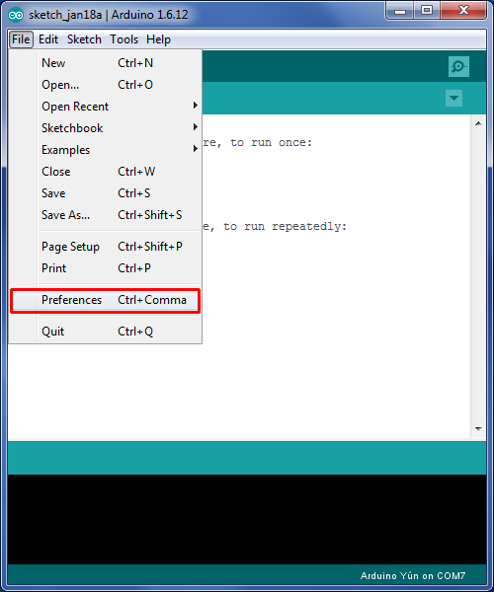
Figure 42 – Arduino IDE Preferences Menu

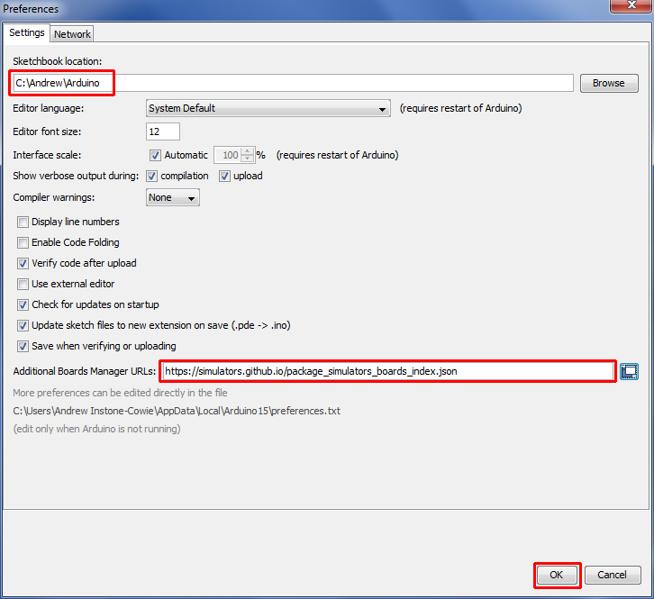
Figure 43 – Arduino IDE Sketchbook Location
- Make a note of the Sketchbook Location path. This is the directory into which the Simulator Interface firmware must be downloaded in a later step.
- Add the URL for the Liverpool Simulator Project boards to the Additional Boards Manager URLs field. The URL is:
https://simulators.github.io/package_simulators_boards_index.json
- Close the preferences dialogue by clicking OK.
- Open the Boards Manager by selecting Tools | Board | Boards Manager.
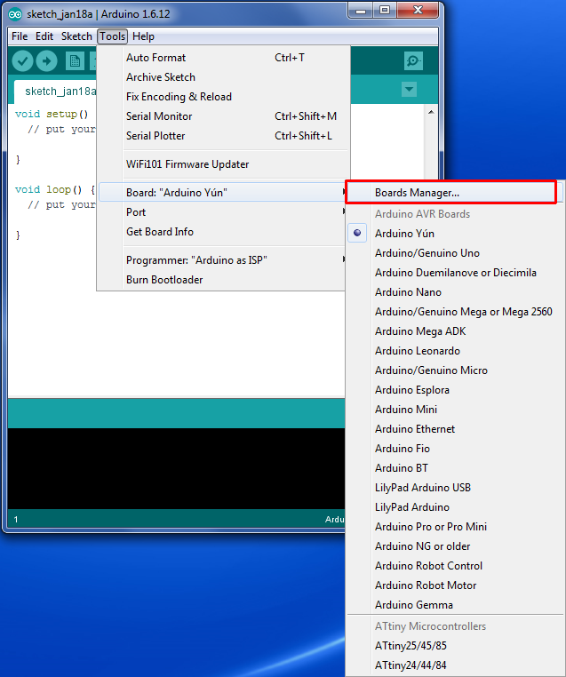
Figure 44 – Arduino IDE Boards Manager Menu

- Scroll down to the entry Liverpool Ringing Simulator Boards, click on the entry, and then click Install. The latest version of the boards package is 1.2.0. Then close the Boards Manager by clicking OK.
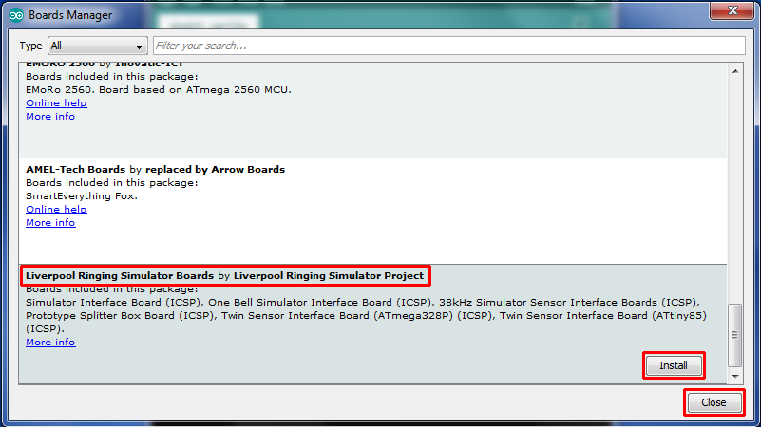
Figure 45 – Arduino IDE Board Manager
- Re-start the Arduino IDE.
The environment is now ready to set up the programmer.

Preparing the Programmer
The programmer is an unmodified Arduino Uno board running a sketch which allows it to operate as an ISP programmer.
This requires an Arduino Uno board, and a Type A to Type B USB cable (sometimes known as a printer cable).
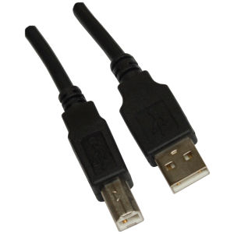
Figure 46 – Arduino USB Cable
The Arduino website has instructions on connecting the Arduino board to a computer, installing drivers and setting up the IDE.
Perform the following steps to prepare the programmer Arduino Uno board:
- Connect the B end of the USB cable to the Arduino Uno board to be used as the programmer. From now on this board is referred to simply as the programmer.
- Connect the A end of the USB cable to the computer.
- Follow the instructions on the Arduino site to install drivers (if necessary), and select the correct port and board type for the programmer in the IDE.
- Open the ArduinoISP software sketch (supplied as part of the default IDE installation) in the Arduino IDE by selecting it from the File | Examples menu.
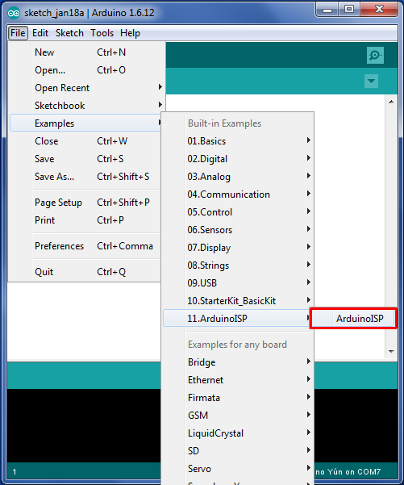
Figure 47 – Arduino IDE ISP Sketch Loading
- On the Tools menu, ensure the correct board type for the programmer is selected (Arduino/Genuino Uno, not Simulator Interface Board (Type 2 Rev E+) (ICSP)) and port. Correct these if necessary.
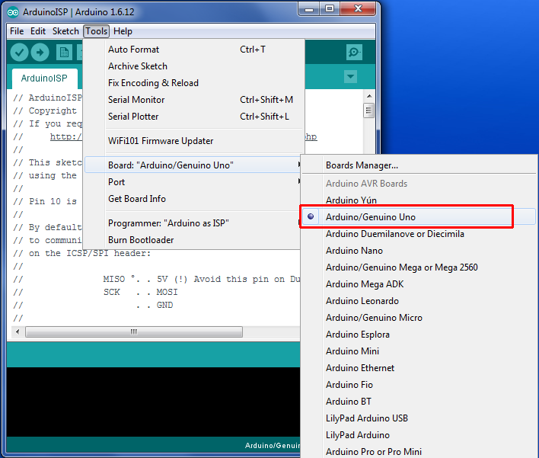
Figure 48 – Arduino Programmer Board Selection
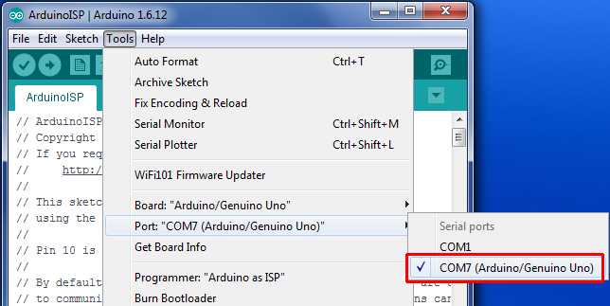
Figure 49 – Arduino Programmer Port Selection
- Click the upload (arrow) button on the IDE toolbar. The ArduinoISP code will be compiled and uploaded to the programmer. Verify that the upload completed successfully by looking for the Done uploading message.
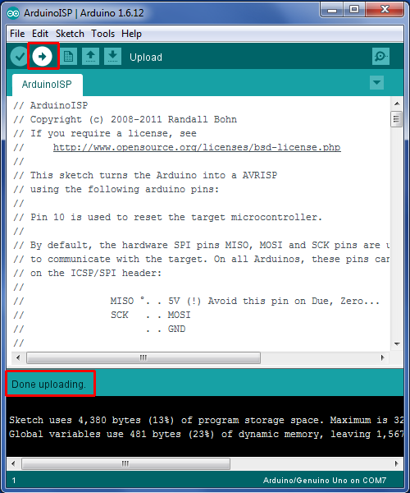
Figure 50 – Arduino IDE ISP Upload
- A failed upload will be indicated by error messages in the status area at the bottom of the IDE window.
- Disconnect the USB cable from the programmer.
- Connect a 10µF 25V electrolytic capacitor between the Reset and Ground pins of the programmer, negative side to Ground. This prevents the IDE from resetting the programmer and overwriting the ArduinoISP software, and allows the IDE to program the Simulator Interface.
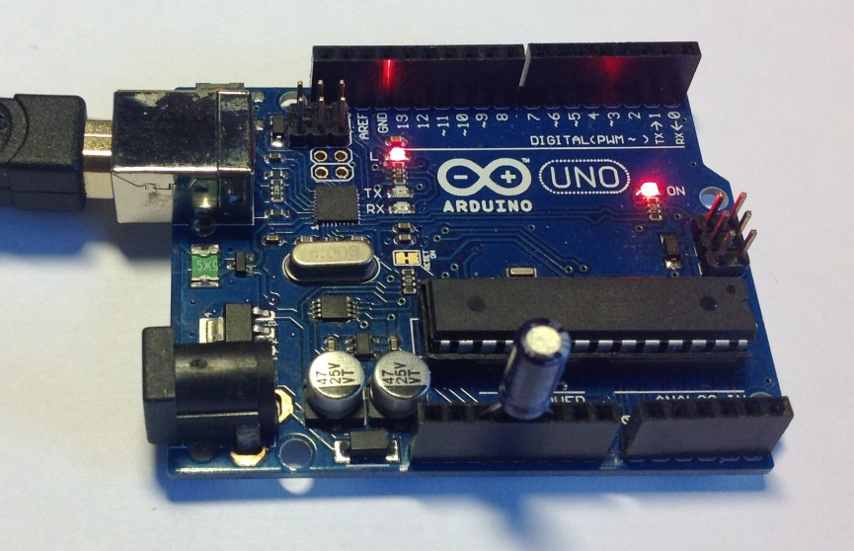
Figure 51 – Programmer with Capacitor
- Reconnect the USB cable to the programmer.
The programmer is now ready for use.

Setting the Fuses
Perform the following steps to set the microcontroller “fuses”. The fuses and their values are explained in the Technical Reference Guide.
- Disconnect the USB cable from the programmer.
- Connect the ICSP pins on the Simulator Interface to the ICSP pins on the programmer with jumper wires as shown in the following diagram.
- Pin 1 on the Simulator Interface PCB is bottom left, identified by a white dot.
- Pin 1 on the programmer is top left. Note that pin 5 on the Simulator Interface PCB is connected to pin 10 on the programmer.
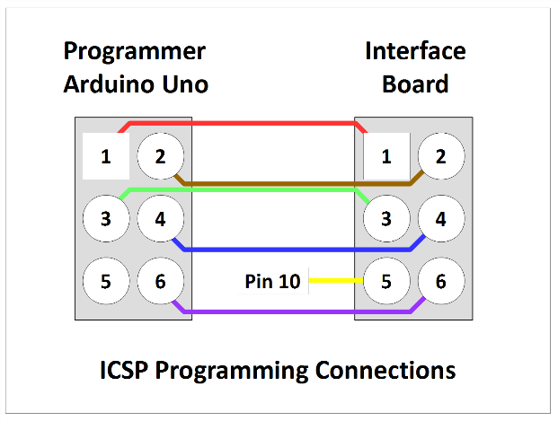
Figure 52 – Programmer Connections
- The following photograph shows the programmer connected to an interface board, including the connection to pin 10 of the programmer (yellow wire), not to the ICSP pin.
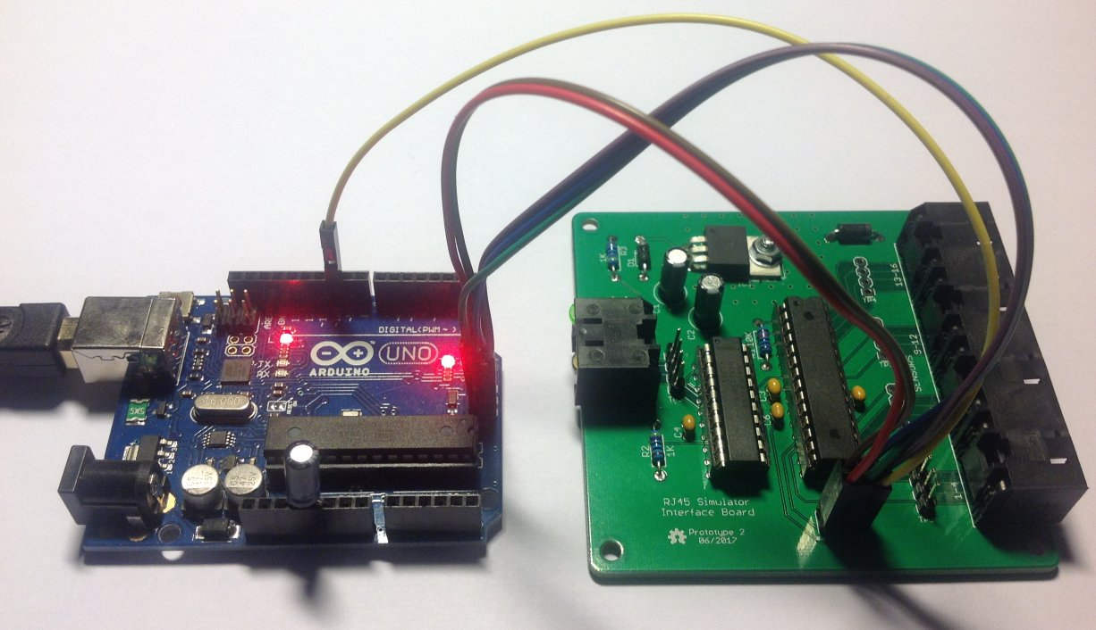
Figure 53 – Programmer Connected to Interface Board
- Reconnect the USB cable to the programmer.
- On the Tools | Board menu, ensure the correct target board type to be programmed has been selected, in this case Simulator Board Interface (Type 2 Rev E+) (ICSP),.
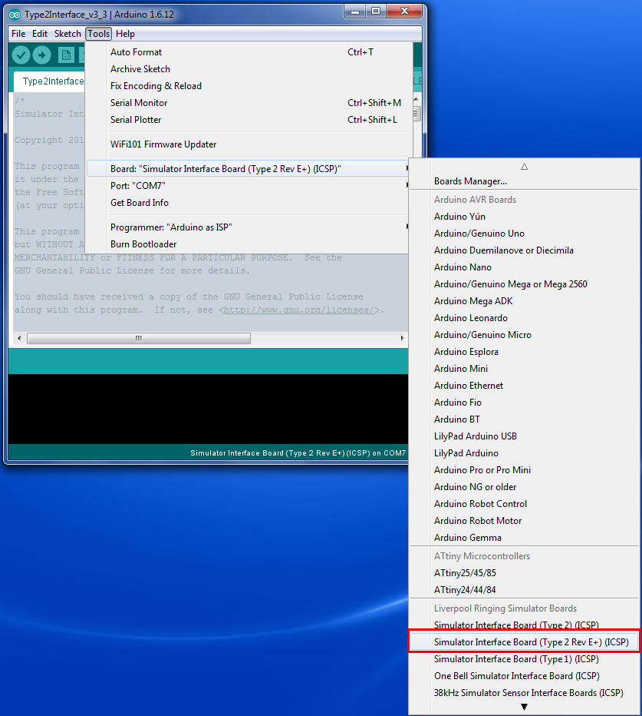
Figure 54 – Arduino IDE Target Board Selection
- On the Tools | Programmer menu, select Arduino as ISP as the programmer type.
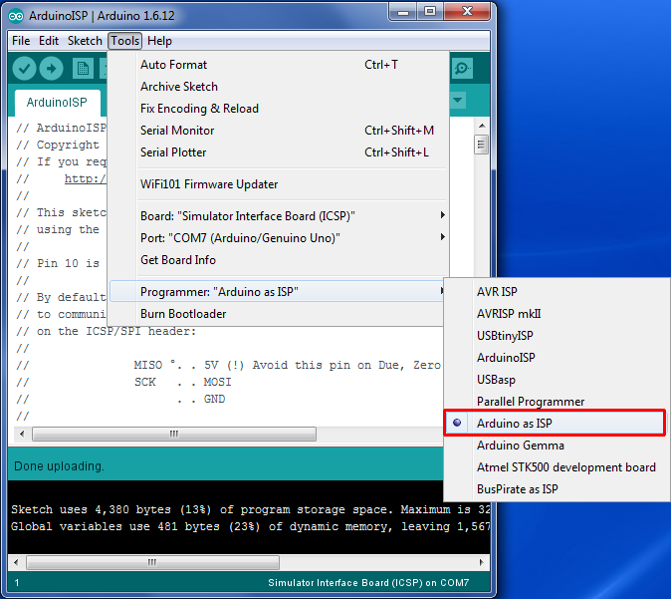
Figure 55 – Arduino IDE Programmer Selection
- On the Tools menu, select Burn Bootloader. The microcontroller fuses on the Simulator Interface Board will be set. Verify that the burn process completed successfully by looking for the Done burning bootloader message.
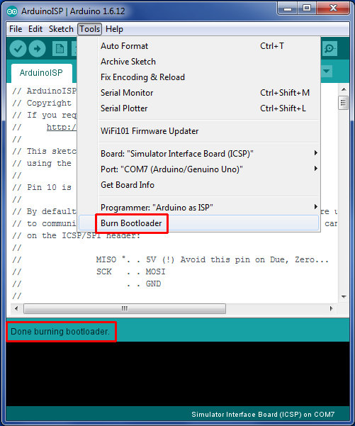
Figure 56 – Arduino IDE Burn Bootloader
- Important note: If a microcontroller previously used in an Arduino board is to be re-used on the Simulator Interface board, carry out the steps above to set the fuses before removing the microcontroller from the donor Arduino. Brand new ATmega328P-PU microcontrollers should be configured to use the 8MHz internal clock by default, but ones previously used on an Arduino will be configured to require an external crystal clock. Once you have set the fuses, move the microcontroller from the donor Arduino to the Simulator Interface Board.
- Note that if new firmware is being uploaded to an existing Simulator Interface Board, there should be no need to go through the steps to set the fuses every time, unless a change in fuse values is required by the new firmware.
The microcontroller is now ready for firmware upload.

Firmware Upload
Perform the following steps to upload the Type 2 Simulator Interface firmware to the board.
- Connect the Simulator Interface Board to the programmer as described in the previous section.
- Download and install the MemoryFree and VTSerial libraries. For convenience these libraries are can also be found in the GitHub repository with the Simulator Interface firmware. Note that the libraries can be installed straight from the compressed zip files by selecting Add .ZIP Library from the Sketch | Include Library menu.
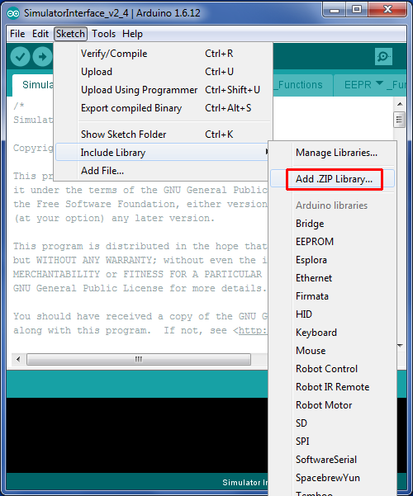
Figure 57 – Arduino IDE Add Library
- Download the Simulator Interface firmware from GitHub and unpack the files into the Arduino IDE sketchbook directory noted earlier. Note that all the firmware files must be unpacked into the directory; it is not possible to compile the firmware code from within a downloaded zip file.
- Load the firmware into the Arduino IDE by double clicking the name of the main file in Windows Explorer, e.g. Type2Interface_v3_2.ino.
- On the Tools | Board menu, as above ensure that the correct board type to be programmed has been selected, in this case Simulator Board Interface (Type 2 Rev E+) (ICSP).
- On the Tools | Programmer menu, as above select Arduino as ISP as the programmer type.
- Click the upload (arrow) button on the IDE toolbar. The Simulator Interface firmware will be compiled and uploaded to the interface board. Verify that the upload completed successfully by looking for the Done uploading message.
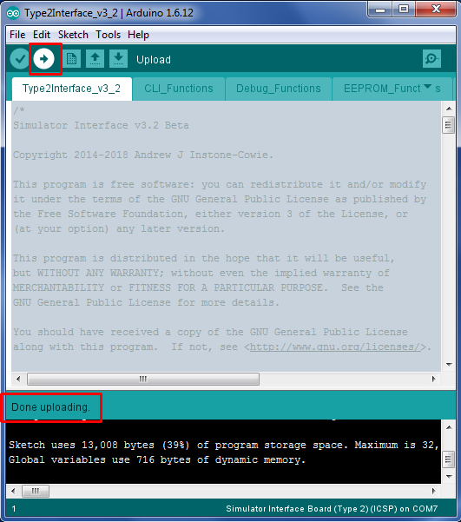
Figure 58 – Arduino IDE Firmware Upload
- A failed upload will be indicated by error messages in the status area at the bottom of the IDE window.
- When the upload has completed the Simulator Interface board will be reset, and on restarting the yellow diagnostic LED will flash according to the firmware version, for example three long and two short flashes indicates firmware version 3.2.
- Disconnect the USB cable from the programmer.
- Disconnect the programmer from the Simulator Interface Board.
- Note that when uploading new firmware to an existing Simulator Interface Board, the Sensor Head Cables and the Power/Data Cable must be disconnected from the Simulator Interface.
The Simulator Interface board now has the firmware installed and is ready for final assembly.

Simulator Installation

Faculty Jurisdiction Rules
If you plan to install a simulator in a tower which falls under the Church of England Faculty Jurisdiction Rules, then from 1st April 2020 you will need the Archdeacon’s formal approval for the installation. Installation of a simulator comes under List B, which covers minor works which can be undertaken with the Archdeacon’s approval, and does not require the granting of a full faculty.
The schedule of rules (as amended in 2024) runs to 73 pages, but the item covering the installation of a simulator can be found under item B2(6) of List B, “installation of an electric silent ringing device for the training of ringers”.

List B Application
The application process is relatively straightforward, and from 06 October 2026 is all handled online via the Church of England Building Management Portal, which can be found here:
https://buildings.churchofengland.org/
The application would usually be made on behalf of the church by an officer of the PCC.
The Liverpool Ringing Simulator Project documentation, or extracts from it, may be used to support your application, provided its source is acknowledged: all documentation is released under the Creative Commons Attribution-ShareAlike 4.0 International License (CC BY-SA) which permits you to re-use it for any purpose as long as you include attribution of the source.

Conditions
There are four standard conditions attached to item B2(6). These are listed and their implications discussed in the following table:
Condition | Implications
Any work to an electrical installation or electrical equipment is carried out by a person whose work is subject to an accredited certification scheme (as defined in rule 3.1(6)). | - This condition is likely to apply only if you require additional socket outlets installing to power the simulator, PC, etc  - This condition essentially means that the church must engage a qualified electrician to do that work.
The device is installed in a location not normally visible to the public. | - Bell chambers and upstairs ringing rooms would not normally be considered visible to the public.  - If the tower is, for example, a ground floor ring open to the body of the church, then you may need to arrange to store the ringing room equipment away when not in use, but that is probably advisable anyway for security.
No alteration is made to the fittings of the bells other than the installation of electric contacts and wires. | - No alteration to the fittings of a bell should be required to install a simulator or sensor.  - The example installations depicted in this guide show how sensor mountings can be devised which require no permanent fixings.  - No modern simulator uses “electric contacts”, and the terminology in this condition is antiquated, but could be construed to apply to optical or magnetic sensors.
The device does not adversely affect the church’s protection against lightning. | - The Liverpool Ringing Simulator design includes Transient Voltage Suppression devices on all signal and data lines. These are intended to protect the simulator itself and any downstream components from transients induced by, for example, nearby lightning strikes. For more information, please refer to the Technical Reference Guide.  - Unless there are very unusual installation requirements, the presence of a simulator should present no additional hazard.
The best advice is, if in any doubt, discuss the installation with the Archdeacon before making an application.

Simulator Interface Module
The Simulator Interface module is located in the belfry, in a location convenient for routing cables to the sensors and the power/data cable down to the ringing room. Try to pick a sheltered location where the interface will be out of the way.
The following picture shows the Simulator Interface module at Lois Weedon in the belfry. Note the two cables for chains of sensors.
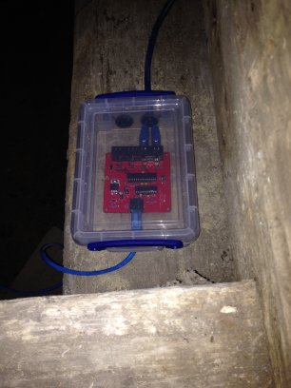
Figure 59 – Installed Simulator Interface
The Simulator Power/Data Cable is routed from the Simulator Interface down to the Power module.
- The cable should be secured to prevent the weight of the cable pulling on the connectors.
- The minimum diameter of any holes along the cable route is approximately 12mm, to allow the RJ45 connector to pass through (unless you are making your own cables in-situ).

Power Module
The Power module enclosure is located near the Simulator PC. There is enough room in the enclosure to house a USB-Serial adapter, if one is required.

Power Supply
A plug-in power supply is required to supply power to the Simulator Interface via the Power Board.
- A regulated DC power supply rated at least 1 Amp with multiple selectable output voltages is recommended, for example Farnell 2802689 or similar.
- The output connector required is 2.1mm x 5.5mm, centre pin positive.
- The output voltage of the power supply should be adjusted so that the supply voltage at the input to the Simulator Interface (measured at TP6) is at least 7.5 volts, with all sensors connected.
- The supply voltage may be higher than that required to maintain 7.5 volts at the Interface, but this will result in increased heat dissipation from the voltage regulator.
- As a guideline, a supply voltage of 9V is generally sufficient to maintain the required voltage, with a 25m Power/Data cable.

Sensor Module Mounting
The magnetic sensors are attached to the bell frame, such that the centre of the magnet is positioned directly opposite the axis of the sensor IC when the bell is down, with a clearance of not more than approximately 30-40mm. The means of mounting the sensors will need to be adapted to suit local conditions, but some examples are shows below.
Sensors can be mounted vertically or horizontally.
The following photographs show magnetic sensors installed at Lois Weedon, using locally made timber brackets clamped around a wooden bell frame with threaded rod. The magnet mounts are also visible.
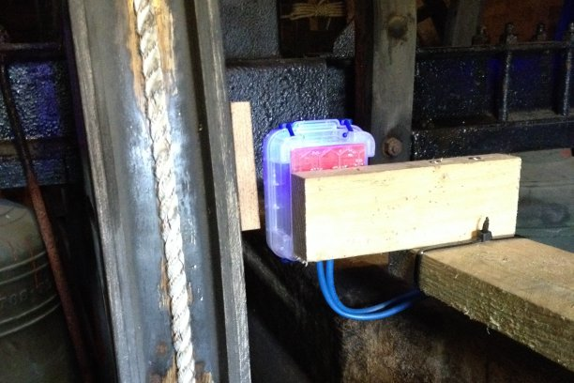
Figure 60 – Installed Sensor (Lois Weedon 4th)
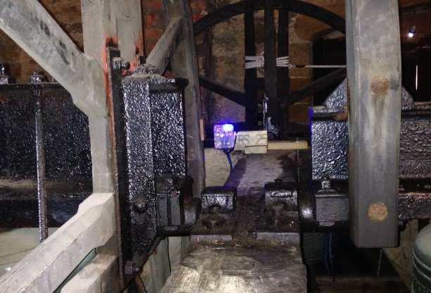
Figure 61 – Installed Sensor (Lois Weedon 6th)
The following photograph shows a (Type 1) optical sensor installed at Chirk, on a timber support secured to the metal bell frame with cable ties. The reflectors on the wheels can also be seen.
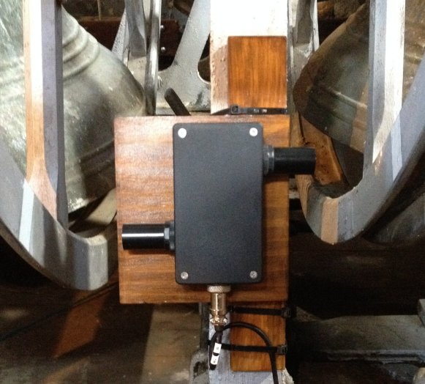
Figure 62 – Installed Sensor (Chirk, Type 1)

Magnet Mounting
The magnetic sensor is triggered by a small rare-earth magnet mounted on the shroud of the wheel, such that the magnet is opposite the centre of the Sensor Head (i.e., co-axial with the 2SS52M sensor IC, or directly opposite the chamfered face of the A1120EUA-T) when the bell is at the bottom of its swing.
The magnet used is a N52 grade rare earth magnet, 20mm diameter x 10mm thick. The following mounting is suggested for a permanent installation: The trigger magnet is mounted in a “flange” cut from 12mm WBP plywood, which is then fixed to the shroud of the wheel using stainless steel screws or double-sided tape.
The dimensions of the mounting flange are show in the following diagram:
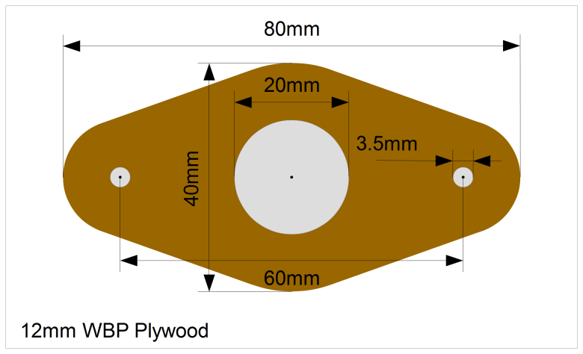
Figure 63 – Magnet Mounting Dimensions
The magnet mountings are constructed as follows:
- The shape of the mounting is marked out on a piece of WBP plywood, 12mm thick. A paper template may be printed out and stuck temporarily to the wood with glue or double-sided tape. A suitable template is available from the GitHub repository as a PDF and should be printed out full size with no scaling.
- The centre hole for the magnet is drilled out with a 20mm spade bit. This should be used in a bench drill press, if available, so that the hole is reasonably accurately cut, and the magnet will be a close fit.
- If the mounting is to be fixed to the wheel with screws, the screw holes are also drilled. It is easier to drill all the holes before cutting the mount to size.
- The mounting is then cut and sanded to shape, and the remains of the template removed. Do not sand the inside of the central hole.

These steps are illustrated in the following series of pictures.
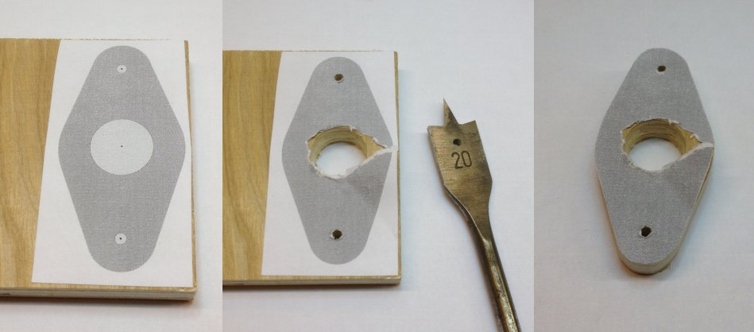
Figure 64 – Magnet Mounting Construction
The magnet is pushed into the central hole, and secured with a small amount of epoxy adhesive (e.g. Araldite). The face of the magnet should be flush with the outer face of the mount, and note that for the Honeywell sensor the polarity of the magnet is not important.
If using the A1120EUA-T device, be sure to mount the magnet the right way round. The A1120EUA-T requires the magnet’s South pole to be facing the device. The South pole of the magnet can be identified with a compass; the South pole will attract the North-seeking end of the compass needle
The following picture shows a completed magnet mounting, ready for painting.
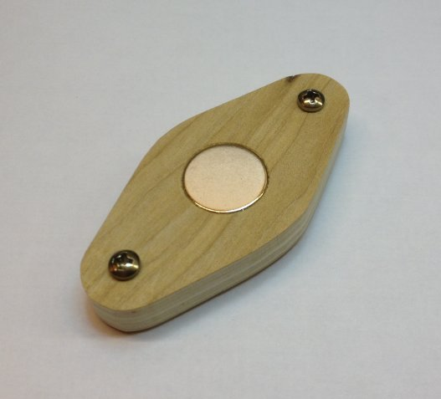
Figure 65 – Completed Magnet Mounting
Care must be taken when handling the rare earth magnets, because they are both powerful and brittle, and can strike a magnetic object with enough force to shatter the magnet. They are also susceptible to corrosion, so must be painted or coated with a thin layer of epoxy.
Once painted the mounting can be fixed the wheel with pan head stainless steel self-tapping screws 3.5mm (No. 6) in diameter and 20mm – 25mm long; the screws should not protrude through the shroud of the wheel. Alternatively, the mount can be secured with double-sided tape, provided the surface of the wheel is sound and free from dust.

Infra-Red Sensors
The sensor is attached to the bell frame in a similar way to a magnetic sensor, such that the sensor masking tube is perpendicular to the face of the shroud of the wheel.

Reflector
The sensor requires a reflector mounted on the shroud of the wheel, such that the reflector is opposite the Sensor Head when the bell is at the bottom of its swing.
The reflector is made from a short length of white reflective automotive styling tape, 25mm wide (which may be obtained from a car spares shop), positioned directly opposite the sensor tube when the bell is down.

Calibration
As supplied, most of the infra-red detector sensor modules have been found to draw approximately 55 – 60mA, much more than the specified 25mA, and were excessively sensitive. The small calibration screw on the back end of the module may be used to reduce both the current consumption and sensitivity of the detector.
A useful starting point for sensitivity adjustment has been found to be to reduce the sensitivity of the sensor such that it does not trigger when placed perpendicular to a piece of grey card at a distance of 90mm from the end of the detector. The multi-turn adjustment screw is turned anti-clockwise until the indicator LED on the back of the module just goes out. This gives an effective maximum trigger distance with the reflective tape of about 300mm. This also reduces the supply current.
Fine adjustment of the sensor should then be carried out in the belfry for optimum sensitivity.

Cabling

Power/Data Cable
The Power/Data Cable runs between the Power module and the Simulator Interface module.
- The cable is a standard straight-through (not crossover) Cat5e or Cat6 Ethernet network cable, with RJ45 connectors. These are available ready-made, for example from Farnell or CPC.
- The maximum length of cable tested is 25m, although longer cables may be feasible.
- Examples of a 25m cable are Farnell part number 2575533 or CPC CS24970.

Sensor Cables
The sensor modules are also cabled back to the Simulator Interface module using standard Cat5e or Cat6 network cables.
- The cables are a standard straight-through (not crossover) Cat5e or Cat6 Ethernet network cable, with RJ45 connectors. These are available ready-made, for example from Farnell or CPC.
- The maximum tested length of a chain of four sensors is 20m, made up of 4 x 5m cables, although longer cables may be feasible.
- Examples of a 5m cable are Farnell part number 1734948 or CPC CS17415.
Sensors are wired in a “daisy chain” fashion, with each chain consisting of a maximum of four sensors. The wiring of one chain is illustrated in the following diagram.
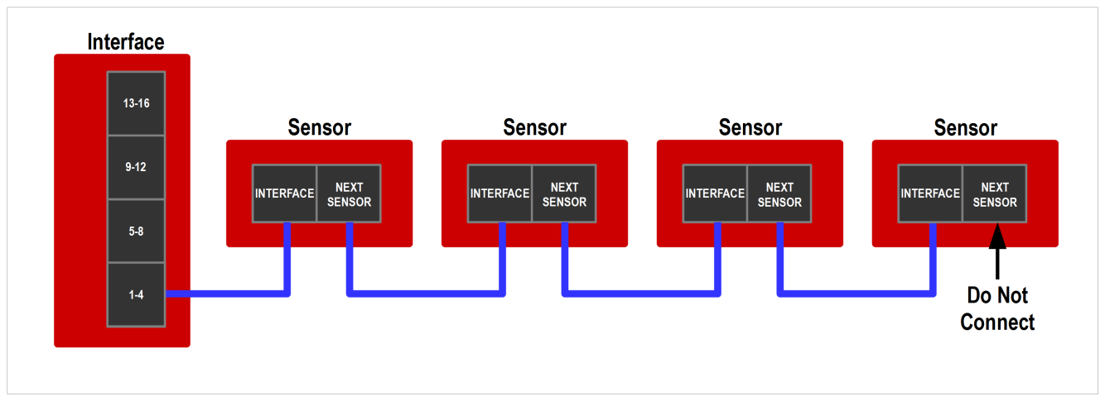
Figure 66 – Sensor Daisy Chain
It is important to understand that there is no requirement to connect any particular sensor to any specific bell, and no requirement that chains should consist of any particular number of sensors.
- The cabling should be arranged to suit the layout and constraints of the belfry.
- The relationship between Simulator Interface channels and bells will be managed in the interface firmware. This is explained in a worked example later in this guide.
- There are obvious constraints for higher numbers of bells: A ring of 12 will require at least three sensors on each chain, and a ring of 16 will require all four chains with four sensors each.

Computer Connection
The simulator Power Board is connected to the Simulator PC in the ringing room with a serial cable. The type of cable required depends on the kind of serial port built into the PC.

9-Pin Serial Connector
The Simulator PC may be fitted with a 9-pin RS-232 serial or “COM” port, as illustrated in the following diagram:
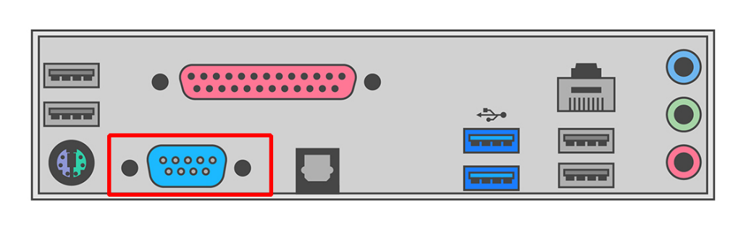
Figure 67 – 9-Pin Serial Port
This type of serial port is common on older computers, but not often found on newer models.
If the Simulator PC has a 9-pin serial port, use a 9-pin Female to 9-pin Male straight-through serial cable to connect the computer to the simulator interface. Examples of suitable cables are Farnell part 2444240 (1.8m), CPC part CS24423 (1m), or CPC part CS24424 (2m).
A typical cable, with the connectors required, is illustrated in the following photograph:
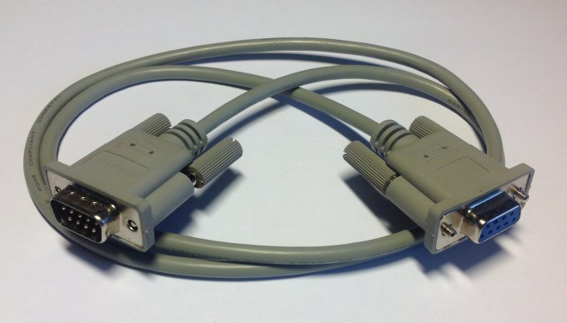
Figure 68 – 9-Pin Serial Cable
If your computer has both a 9-pin serial port and USB ports, use the 9-pin serial port.

USB Connector
More modern computers are likely to be fitted only with USB ports, as illustrated in the following diagram:
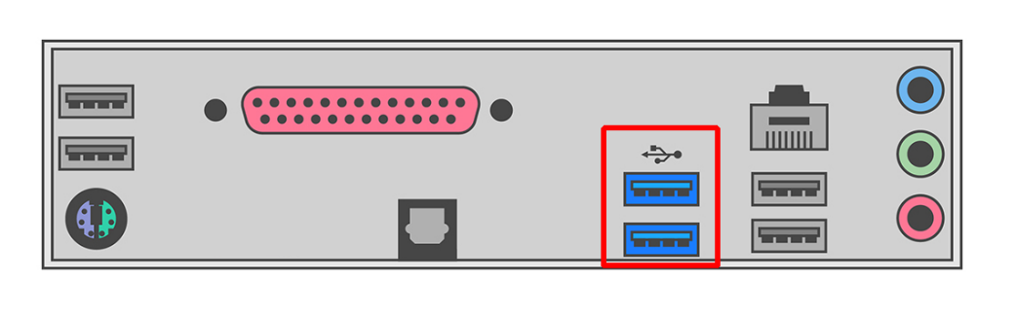
Figure 69 – PC USB Ports
In this case, use a USB-Serial adapter to connect the simulator Power Board to a spare USB port on the Simulator PC. If necessary, a straight through serial cable as above can be used as an extension.
An example of a typical USB-Serial adapter is illustrated in the following photograph. Note that an extension cable may be required if (as in this case) the adapter does not have securing screws.
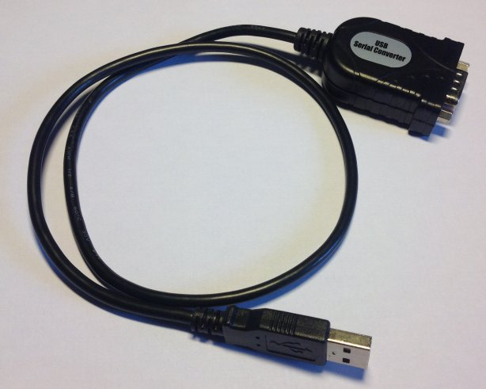
Figure 70 – USB to Serial Adapter
Install the drivers supplied with the adapter and identify the COM port number allocated (you will need to know this later to configure your Simulator Software Package).
There is more information on USB-Serial adapters in the Technical Reference Guide.

Interface Module Setup
The Type 2 Liverpool Simulator Interface module is highly configurable, but most of the default settings should be fine for most installations. There is detailed information about all the configuration options in the Technical Reference Guide.
There are a couple of configuration options which you should set before using the simulator: disabling unused sensor channels, and re-mapping sensors to bells. Configuration of the Simulator Interface should only need to be done once. All settings are retained in non-volatile EEPROM when the interface is powered off.
Note: When multiple PCs are connected, only one PC can be used to configure the Simulator Interface using a terminal emulator. Refer to the Multi-PC Guide for more information.

Connecting to the Interface Module
- On the Simulator PC, ensure that a Simulator Software Package (e.g. Abel) is not running. Close the Simulator Software Package down if it is running.
- Download and install a serial terminal emulator package. This manual assumes the use of the Open Source PuTTY terminal emulator.
- Start the PuTTY terminal emulator by double-clicking the PuTTY icon on the desktop.

- Configure a Serial connection using the COM port number of the serial port (e.g. COM1), running at 2400 bps, and then click Open. You should not need to change any other settings in PuTTY.
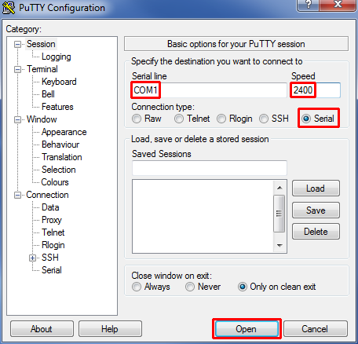
Figure 71 – PuTTY Configuration Dialogue
Click on the PuTTY terminal window, then type “?” (question mark). There is no need to press Enter. After a short pause the Simulator Interface will respond by displaying its current settings, which may not be identical to these examples.
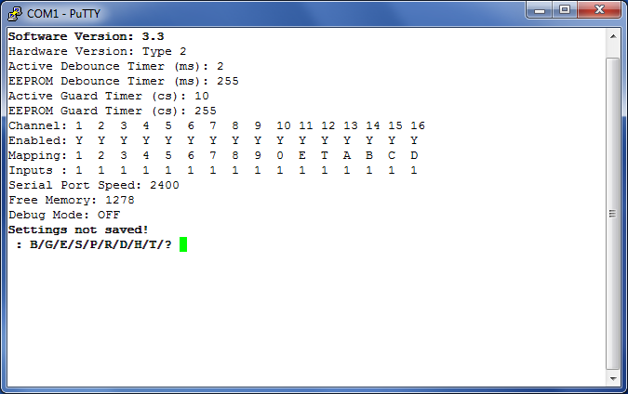
Figure 72 – Display Interface Settings

Worked Example
The following worked example shows how to disable unused sensor channels, and re-map channels when setting up the Simulator Interface. You should adapt the instructions in the worked example to suit your installation.

Sensor Channels
Before configuring the interface, it is important to understand the difference between interface sensor channels numbers, and numbers of the bells. The channel numbers are fixed as shown in the diagram below: Channel 1 is always the first sensor on the first chain, channel 2 is always the second sensor on the first chain, and so on up to channel 16.
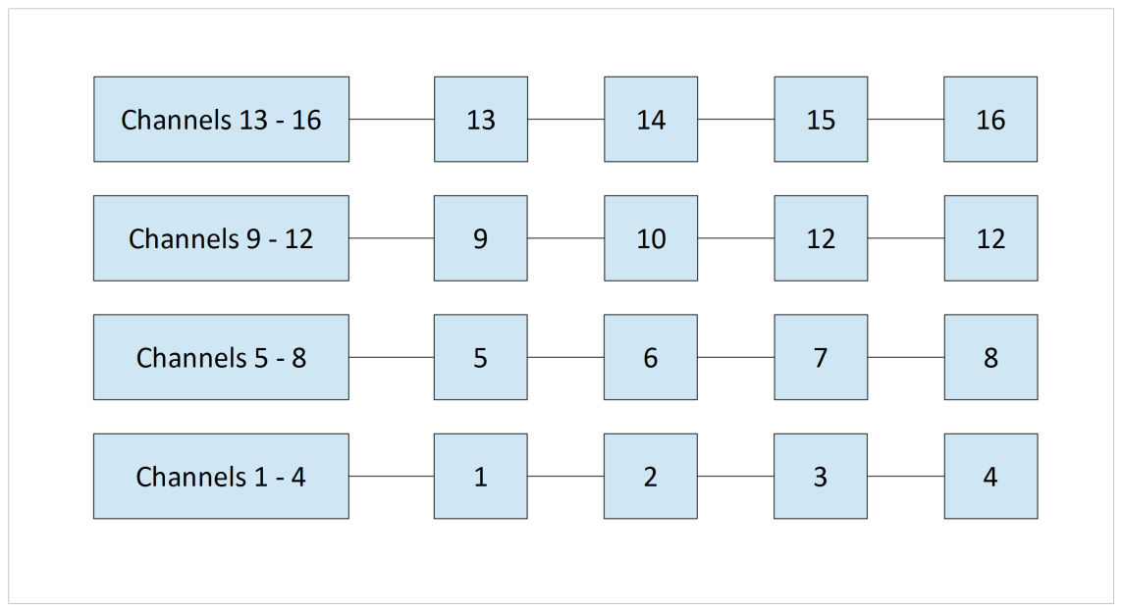
Figure 73 – Interface Channel Numbers
To re-iterate the guidance in the previous section, there is no requirement to connect any particular sensor to any specific bell, and no requirement that chains should consist of any particular number of sensors. The sensor cabling should be arranged to suit the layout and constraints of the belfry.

Example Installation
The diagram below shows the sensor cabling for a mythical ring of six. The cables between the sensors and the interface have been routed as shown, to avoid the clock wires, chiming hammers, rope chutes and all the other things which clutter up the belfry. This example is deliberately convoluted to show how the interface settings can be configured.
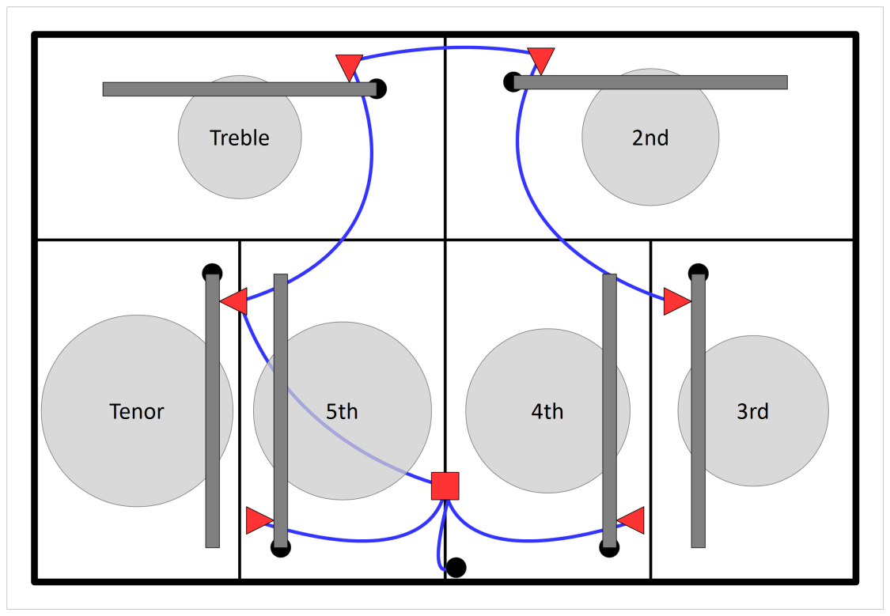
Figure 74 – Example Sensor Cabling
As a result, the sensors on the bells are connected to the following channels. Channels 6, 7, 8, and 10 to 16 are not used.
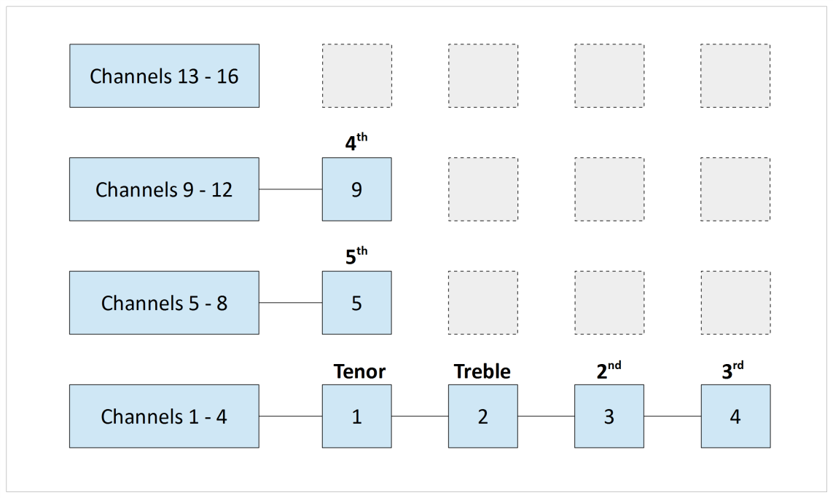
Figure 75 – Example Channel Connections
These unused channels will be disabled on the simulator interface. There is no point scanning these channels for sensor signals, as there are no sensors connected to them.
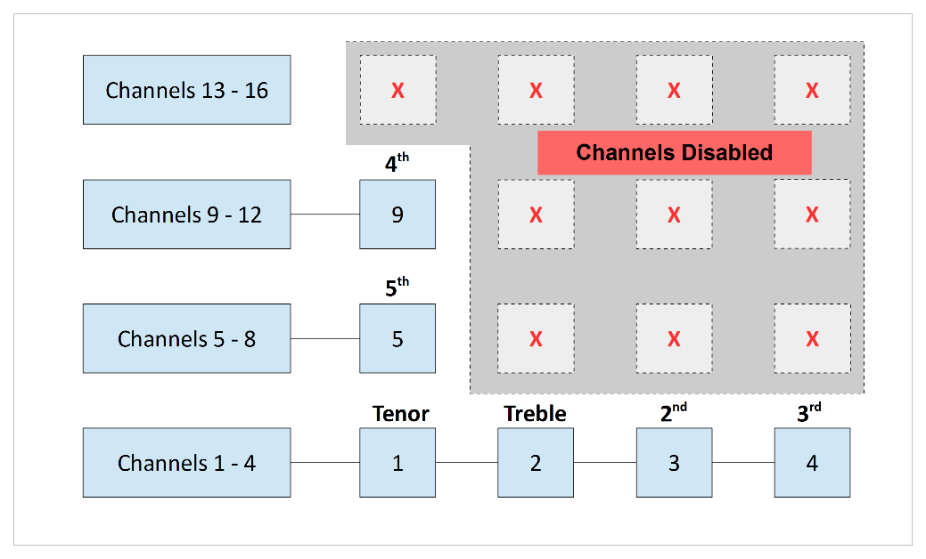
Figure 76 – Disabled Channels

Default Settings
Open a terminal session to the interface using PuTTY, as described above.
- The “?” command shows the default settings:
Figure 77 – Default Settings

Disable Unused Channels
- To disable (or enable) channels, use the “E” command. There is no need to press Enter after typing the “E”.
- Enter the number of each channel to be disabled, pressing Enter after each one. In the example below, channels 6, 7, 8, and 10 to 16 are disabled.
- When you have finished, enter a zero (or just press Enter).
- The interface software will not allow you to disable all the sensors.
- These settings are not saved yet and will revert to the defaults if the interface power is turned off. The settings will be saved later.
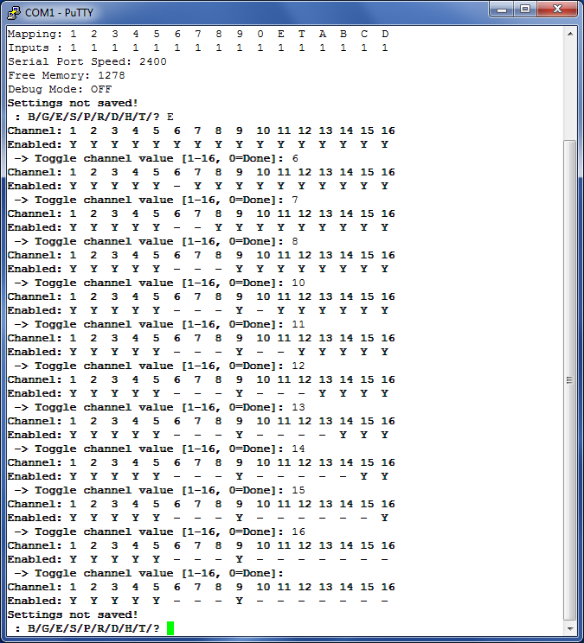
Figure 78 – Disabling Channels Example

Re-Map Channels to Bells
Although the mapping between the channel/sensor numbers and the real bell numbers can be reconfigured in most Simulator Software Packages, it is less confusing if this is set in the simulator interface.
In the example installation above, the interface channels are mapped to the real bells as follows:
Table 7 – Example Channel Mapping
Channel | Bell
1 | 6
2 | 1
3 | 2
4 | 3
5 | 5
9 | 4

- To re-map a channel to a real bell number, use the “R” command. There is no need to press Enter after typing the “R”.
- Enter the number of each channel to be remapped, and press Enter.
- Then enter the number (or letter) of bell to which that sensor is attached, and press Enter. The numbers and letters follow the usual ringing conventions, as shown in the table below:
Table 8 – Bell Numbers & Letters
Bells | Bell Numbers/Letters
1 to 9 | 1 – 9
10 | 0
11 | E
12 | T
13 to 16 | A – D
Switches | W – Z

- Letters W, X, Y and Z are used in Abel switch configurations, and are not normally used. More information on switches can be found in the Technical Reference Guide.
- Repeat for all the other channels to be re-mapped. In the example below, channels 5 is already allocated to the 5th, so no re-mapping is needed.
- When you have finished, enter a zero (or just press Enter).
- The interface software will warn you if duplicate mappings are defined, but will not prevent you from saving such a configuration.
- These settings are not saved yet and will revert to the defaults if the interface power is turned off. The settings will be saved later.

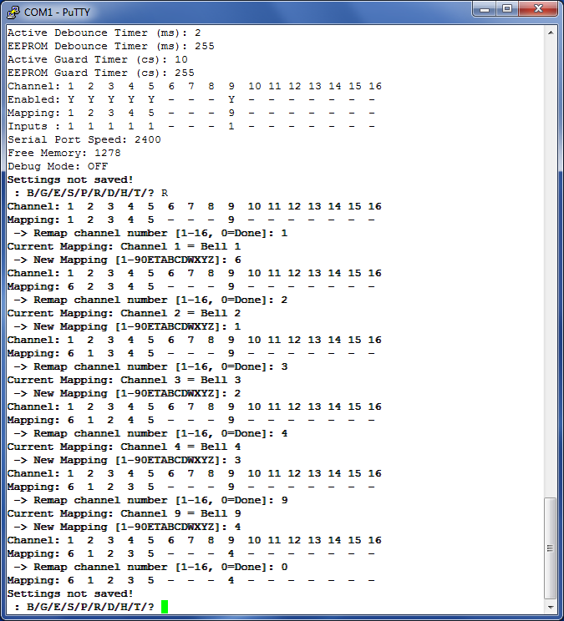
Figure 79 – Channel Re-Mapping Example

Save Settings
- Review your settings with the “?”command.
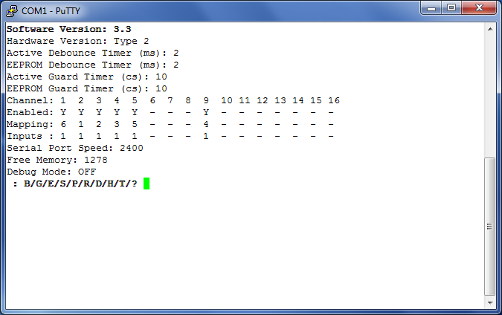
Figure 80 – Example Channel Connections
- Finally, save the settings using the “S” command, and then close the terminal window.
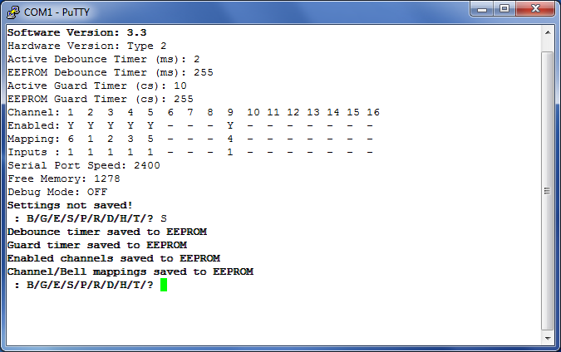
Figure 81 – Saving Interface Settings

Next Steps
You are now ready to move on to configure your chosen Simulator Software Package to work with the simulator. Instructions for configuring the main Simulator Software Packages can be found in the following guides:
- Configuring Abel Guide
- Configuring Beltower Guide
- Configuring Virtual Belfry Guide
If your Simulator Software Package is not listed above, please refer to the vendor’s instructions on configuring their software to work with external sensors.
If you want to use multiple PCs concurrently, see the Multi-PC Guide for more information.

Licensing & Disclaimers

Documentation
All original manuals and other documentation (including PCB layout CAD files and schematics) released as part of the Liverpool Ringing Simulator project are released under the Creative Commons Attribution-ShareAlike 4.0 International License (CC BY-SA), which includes the following disclaimers:
Unless otherwise separately undertaken by the Licensor, to the extent possible, the Licensor offers the Licensed Material as-is and as-available, and makes no representations or warranties of any kind concerning the Licensed Material, whether express, implied, statutory, or other. This includes, without limitation, warranties of title, merchantability, fitness for a particular purpose, non-infringement, absence of latent or other defects, accuracy, or the presence or absence of errors, whether or not known or discoverable. Where disclaimers of warranties are not allowed in full or in part, this disclaimer may not apply to You.
To the extent possible, in no event will the Licensor be liable to You on any legal theory (including, without limitation, negligence) or otherwise for any direct, special, indirect, incidental, consequential, punitive, exemplary, or other losses, costs, expenses, or damages arising out of this Public License or use of the Licensed Material, even if the Licensor has been advised of the possibility of such losses, costs, expenses, or damages. Where a limitation of liability is not allowed in full or in part, this limitation may not apply to You.

Software
All original software released as part of the Liverpool Ringing Simulator project is released under the GNU General Public Licence (GPL), Version 3, and carries the following disclaimers:
This program is free software: you can redistribute it and/or modify it under the terms of the GNU General Public License as published by the Free Software Foundation, either version 3 of the License, or (at your option) any later version.
This program is distributed in the hope that it will be useful, but WITHOUT ANY WARRANTY; without even the implied warranty of MERCHANTABILITY or FITNESS FOR A PARTICULAR PURPOSE. See the GNU General Public License for more details.

Acknowledgements
The Liverpool Ringing Simulator project relies extensively on work already undertaken by others, notably David Bagley (developer of the Bagley MBI), Chris Hughes and Simon Feather (developers of the Abel simulator software package), Derek Ballard (developer of the Beltower simulator software package), Doug Nichols (developer of the Virtual Belfry simulator software package), and others. Their invaluable contributions are hereby acknowledged. Sources used are referenced in the footnotes throughout.
Thanks are also owed to the Ringing Masters and ringers of the following towers for their willingness to be the crash test dummies of simulator design and testing.
- Liverpool Cathedral
- St George’s, Isle of Man
- St Mary, Chirk, Wrexham
- St John, Higham, Kent
- St Margaret, Crick, Northamptonshire
- St Mary & St Peter, Lois Weedon, Northamptonshire
Really Useful Box ® is a registered trademark of Really Useful Products Ltd.

https://creativecommons.org/licenses/by-sa/4.0/
https://www.abelsim.co.uk
https://www.beltower.co.uk
https://www.belfryware.com
Printed Circuit Board
This price is for HASL finish leaded solder PCBs, other finishes have higher costs.
Panelized boards pricing is slightly more complex, but handled automatically by the fabrication service.
A single set of Gerber files is provided, which should be suitable for all the manufacturers mentioned.
If you require lead-free boards for commercial reasons, specify Lead-Free HASL or ENIG. There is an additional cost for these finishes.
Permalinks to OSH Park are no longer provided in this document. Always upload the latest Gerber files from GitHub when ordering.
In-Circuit Serial Programming
Multi-Layer Ceramic Capacitor
PCB Revision E onwards
Not required if you have obtained a microcontroller from the project with the firmware already loaded.
From PCB Revision C onwards only. Do not use this method with older boards, the voltage regulator alignment was adjusted in Revision C for this purpose.
http://www.gremlyn.plus.com/ahme/mag_sen.html
https://sps.honeywell.com/us/en/products/advanced-sensing-technologies/industrial-sensing/industrial-sensors/magnetic-sensors/omnipolar-position-sensor-ics/2ss52m-series
https://www.allegromicro.com/en/products/sense/switches-and-latches/three-wire-hall-effect-switches/a1120-1-2-5
PCB Revision E or later is required for the A1120EUA-T Hall Effect device option. Earlier revisions support the 2SS52M device only.
The Amphenol RJHSE-5080-02 connector originally specified is no longer stocked by Farnell. The alternative AMP TE Connectivity part 5406526-1 is a direct replacement.
See Technical Reference Guide for more information.
The Amphenol RJHSE-5080-02 connector originally specified is no longer stocked by Farnell. The alternative AMP TE Connectivity part 5406526-1 is a direct replacement.
https://hobbycomponents.com/sensors/213-ir-infrared-obstacle-avoidance-sensor-e18-d80nk
https://shop.4tronix.co.uk/collections/sensors/products/ir-infrared-obstacle-sensor
https://www.reallyusefulproducts.co.uk/
Frequently used by electricians.
https://www.microchip.com/developmenttools/ProductDetails/atatmel-ice
https://www.arduino.cc/en/Main/ArduinoISP
https://www.arduino.cc/en/Tutorial/ArduinoISP
https://www.arduino.cc/en/Main/Software
If the Liverpool Ringing Simulator Project boards are not listed, go back and check that the boards have been installed in the Boards Manager.
Select “Simulator Board Interface (Type 2 Rev E+) (ICSP)” for Interface PCB Rev E and later. For Rev D and earlier, select “Simulator Board Interface (Type 2) (ICSP)”
https://github.com/maniacbug/MemoryFree
The original source of the VTSerial library is no longer available. Use the copy included in the GitHub repository.
“[List B] prescribes matters which may, subject to any specified conditions, be undertaken without a faculty if the archdeacon has been consulted on the proposal to undertake the matter and has given notice in writing that the matter may be undertaken without a faculty. The archdeacon may impose additional conditions in the written notice.”
List A covers minor works for which no prior approval is required. Works on List B require the Archdeacon’s approval, and everything else requires the granting of a full faculty.
https://www.churchofengland.org/sites/default/files/2024-07/list_a_b_2024.pdf
The former Online Faculty System was replaced by the Building Management Portal in October 2026.
A “straight-through” cable has pin 1 wired to pin 1, pin 2 to pin 2, and so on. Do not use a “null modem” cable, which has more complex internal wiring and is not suitable.
If your computer has only “USB-C” ports then you will require a different adapter.
https://www.chiark.greenend.org.uk/~sgtatham/putty/
The default PuTTY colour scheme is white (or coloured) text on a black background. In these examples this has been reversed and reduced to black on white for better printing.
You may have a single interface serving both a ring of real bells and a set of training dumb bells, for example.
https://www.simulators.org.uk/
https://creativecommons.org/licenses/by-sa/4.0/
https://www.gnu.org/licenses/gpl-3.0.en.html

